Name

Mathematics Stage 4
Computation with Integers

Book 1 |  | Version: 260916  Feedback:  https://MrDingMaths.com
Contents
Syllabus Content 2
Introduction to Integers 5
Comparing and Ordering Integers 13
Opposite Integers 17
The Negative Symbol 18
Adding and Subtracting Positive Integers 20
Mental Shortcuts for Adding and Subtracting Integers 27
Adding and Subtracting Negative Integers 30
Multiplying and Dividing Integers 40
Mixed Practice 47
Order of Operations with Integers 54
Challenge Exercise 62

Syllabus Content
MA4-INT-C-01 compares, orders and calculates with integers to solve problems
Compare and order integers
- Recognise and describe the direction and magnitude of integers
- Identify and represent integers on a number line
- Compare the relative value of integers using the less than (<) and greater than (>) symbols
- Order integers
Add and subtract positive and negative integers
- Add and subtract integers with and without the use of digital tools
- Construct a directed number sentence to model a situation
- Examine different meanings (position or operation) for the + and - signs, depending on context
Multiply and divide positive and negative integers
- Represent multiples of negative integers as repeated addition
- Multiply and divide positive and negative integers with and without the use of digital tools
Apply the 4 operations to integers
- Apply the 4 operations to integers
- Solve problems involving grouping symbols with integers
- Apply the order of operations to evaluate expressions involving integers, with and without the use of digital tools

Introduction to Integers

- Review
- Work with whole numbers
- Circle the calculations below that will have an answer less than zero.

- Starting at 10, count down by 2s until you get to $-10$
10, ……, ……, ……, ……, ……, ……, ……, ……, ……, ……

- Starting at 30, count down by 5s until you get to $-10$
………………………………………………………………………………………………………

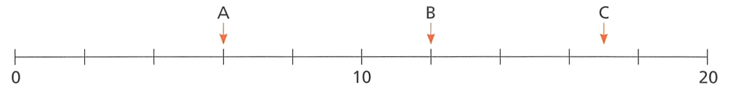
- What numbers are the arrows pointing to?

- Circle the greater number in each pair.

- Use the words equal to, greater than, or less than to complete the statements, then write a statement using $<or >$
  - 42 is ……………………… 24 42 …… 24
  - 39 is ……………………… 99 39 …… 99
  - 1000 is ……………………… 900 1000 …… 900
  - 21 …………………… 50 21 …… 50

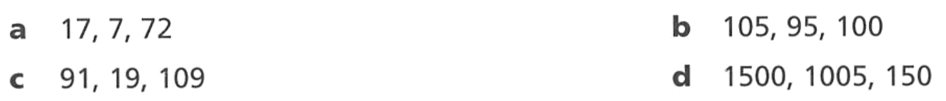
- Arrange these numbers in ascending order.

- Integers
An integer is a whole number.
Integers include positive whole numbers, negative whole numbers, and zero.
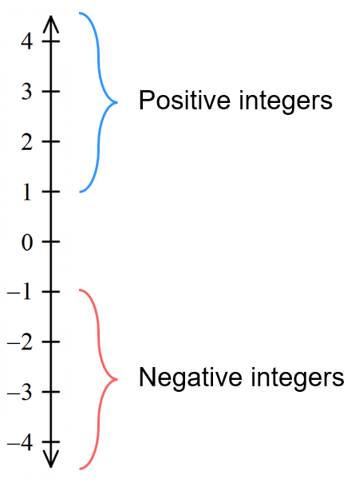
Positive integers are greater than zero
Positive integers may be written with a $+$ sign or no sign.
(e.g. $+5$ or $5$)

Negative integers are less than zero.
Negative integers are always written with a $-$ sign.
(e.g. $-5$)

We use negative numbers to represent temperature,
owing money (debt), altitude, etc.

- Identify integers
✖  $$\frac{3}{4}$$ | ✔  $$3$$ |  | ✔  $$0$$ |  | ✔  $$-49$$ |  | ✖  $$-4.9$$
Identify which of the following are integers.
- $7$ |  | - $-821$ |  | - $9.2$ |  | - $-$ $\frac{1}{2}$
- $0$ |  | - $+22$ |  | - $3\frac{4}{5}$ |  | - $-0.23$

- Key Ideas
- Integers are ……………… numbers.
- Integers can be positive, n…………………, or zero.
- A negative integer has a ……… sign in front of it.
- Positive integers are ………… than zero.
- Negative integers are ………… than zero.
- Zero is neither …………… nor ………………

- Magnitude and Direction
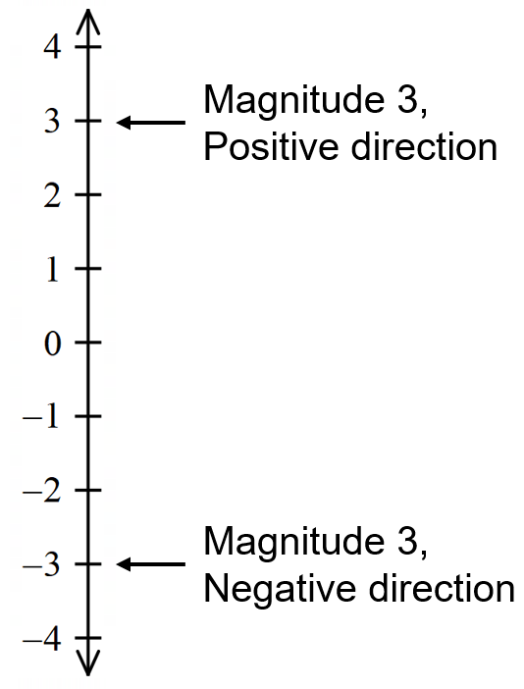
Every integer has two properties: magnitude and direction.

Magnitude is the distance from zero.

Direction is positive or negative.

- Identify Magnitude and direction of integers
Integer | Magnitude | Direction |  | Integer | Magnitude | Direction
$$4$$ |  |  |  | $$-21$$
$$3$$ |  |  |  | $$-38$$
$$-3$$ |  |  |  | $$+38$$
$$+3$$ |  |  |  |  | 18 | Positive
$$-5$$ |  |  |  |  | 83 | Negative
$$16$$ |  |  |  |  | 57 | Negative

- Integers on a Number Line
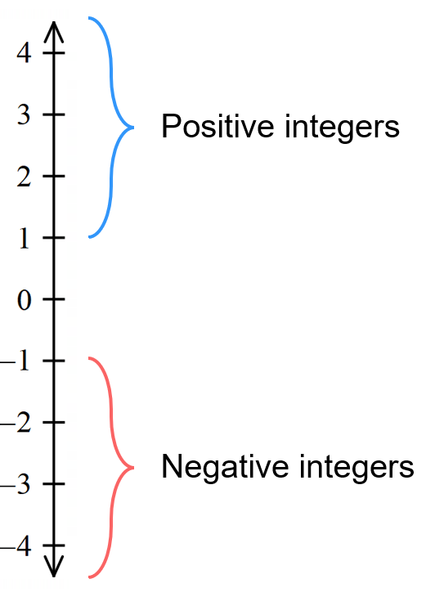
We can represent integers as values on a number line.
A negative integer is to the left of zero, or below zero.
A positive integer is the to the right of zero, or above zero.

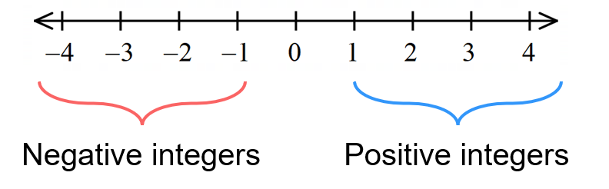

On a number line, each interval, or gap, represents the same amount.

- Complete Number lines
 | 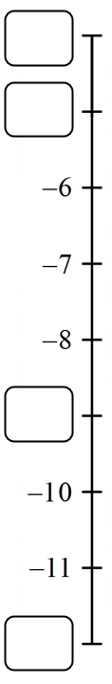  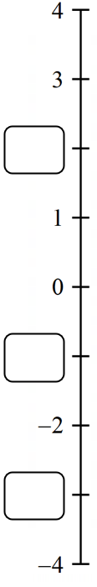 | 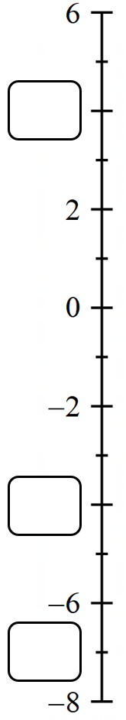 | 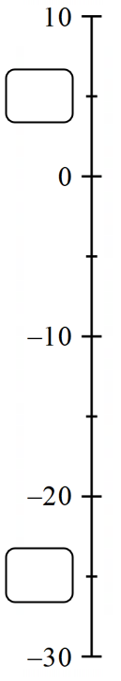
- What numbers are the arrows pointing to?

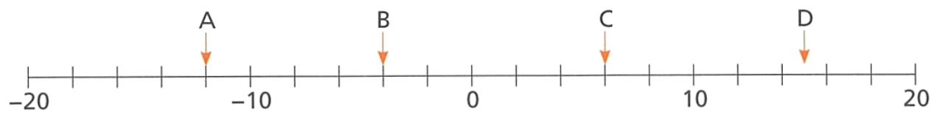

Foundation
- Find the missing number on the number line.
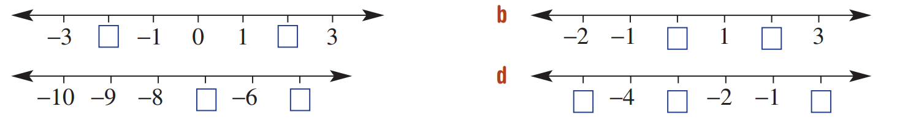  a  $$-2,2$$ | b  $$0, 2$$
c  $$-7. -5$$ | d  $$-5,-3,0$$

- Write an integer that represents these scenarios:
  - The temperature today is 7 degrees below zero.
$$-7$$
  - The carpark is 4 floors below ground.
$$-4$$
  - The penthouse is on the 10th floor.
$$10$$
  - Mount Everest is 8849 m above sea level.
$$8849$$
  - The Dead Sea is 422 m below sea level.
$$-422$$
  - The share market dropped 3 points.
$$-3$$
  - James received $5 for doing the laundry.
$$5$$
  - Chloe borrowed $30 from her mother.
$$-30$$
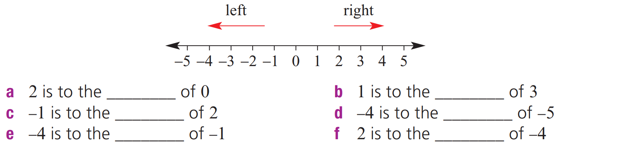
- Add the word right or left to make the following statements true. Use this number line to help.

Right | Left
Left | Right
Left | Right

Development
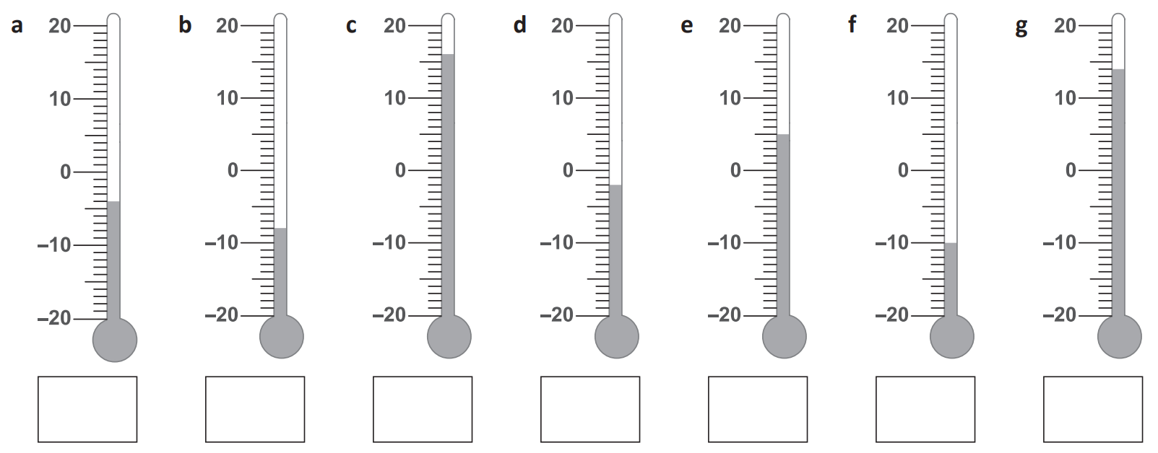
- What is the temperature showing on each thermometer?

$-4$ $-8$ $16$ $-2$ $5$ $-10$ $14$
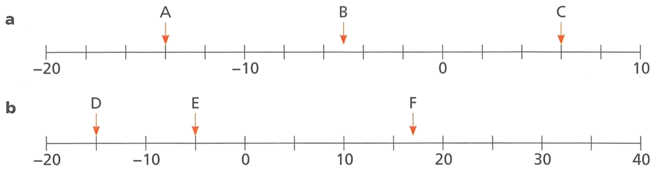
- What numbers are the arrows pointing to?

A: $-14$, B: $-5$, C: $6$

A: $-15$, B: $-5$, C: 17

- Show these sets of numbers on a number line.
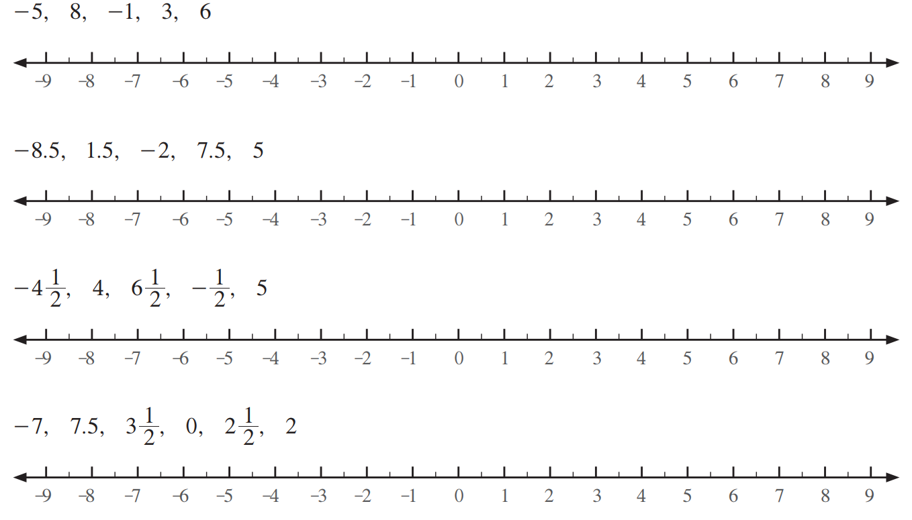

- Write all the integers counting up from $-29$ to $-19$
$-29, -28,$ ……………………………………………………………………………………………
$$-27, -26, -25, -24, -23, -22, -21, -20, -19$$
- Count down by 3s from $11$ to $-16$
$11, 8,$ ……………………………………………………………………………………………
$$5, 2, -1, -4, -7, -10, -13, -16$$
- Count up by 7s from $-32$ to $17$
$-32, -25,$ ……………………………………………………………………………………………
$$-18, -11, -4, 3, 10, 17$$
- Count down by 13s from $17$ to $-48$
………………………………………………………………………………………………………………
$$4, -9, -22, -35, -48$$
- Count up by 6s from $-40$ to $14$
………………………………………………………………………………………………………………
$$-40, -34, -28, -22,-16, -10, -4, 2, 8, 14$$
- Write the next three numbers in these simple patterns.
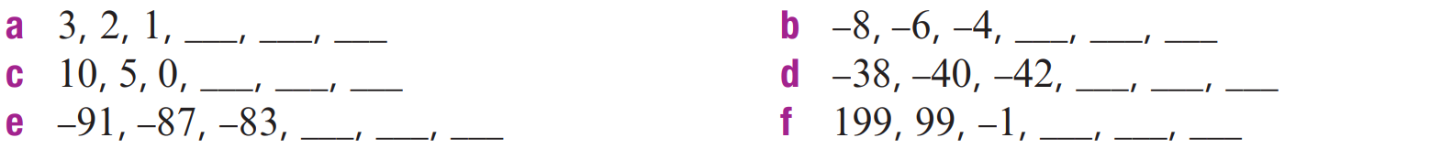  0, $-1$, $-2$ | $$-2, 0 , 2$$
$$-5, -10, -15$$ | $$-44,-46,-48$$
$$-79, -75, -71$$ | $$-101, -201, -301$$

- What number is halfway between:
- $-2$ and 6  2 | - $-5$ and 3  $$-1$$

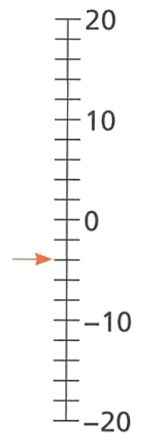
- Yasmin says that the arrow is pointing to $-2$. Explain why she is incorrect.

Each interval represents 2, so the arrow is pointing to $-4$
Draw arrows to these numbers:
  - $6$
  - $-6$
  - $12$
  - $-13$

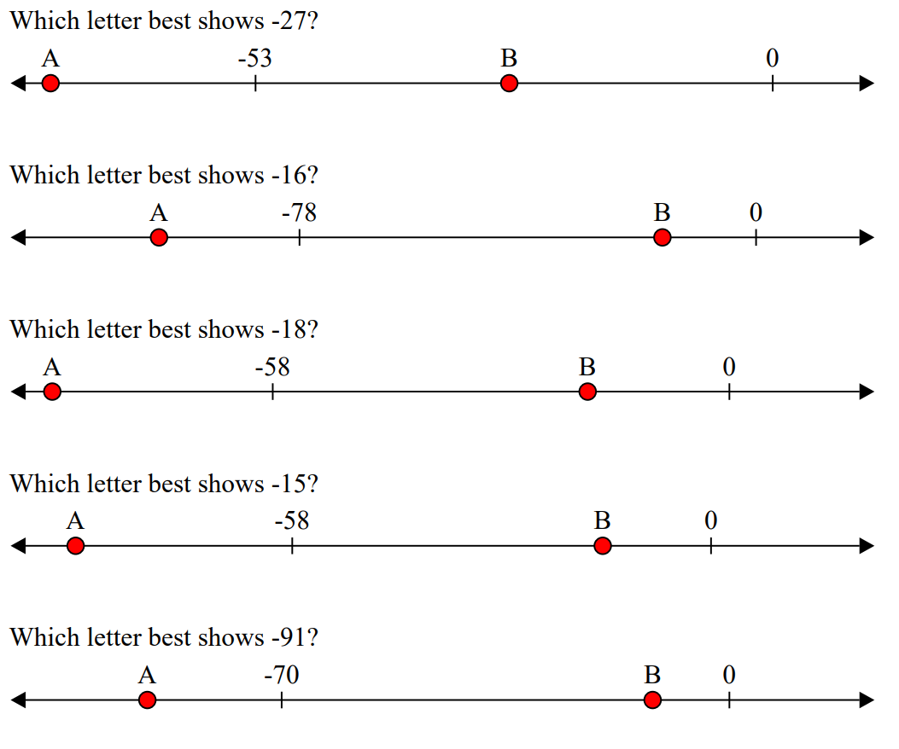
- Decide which letter represents:
  - $-27$ ……
B
  - $-16$ ……
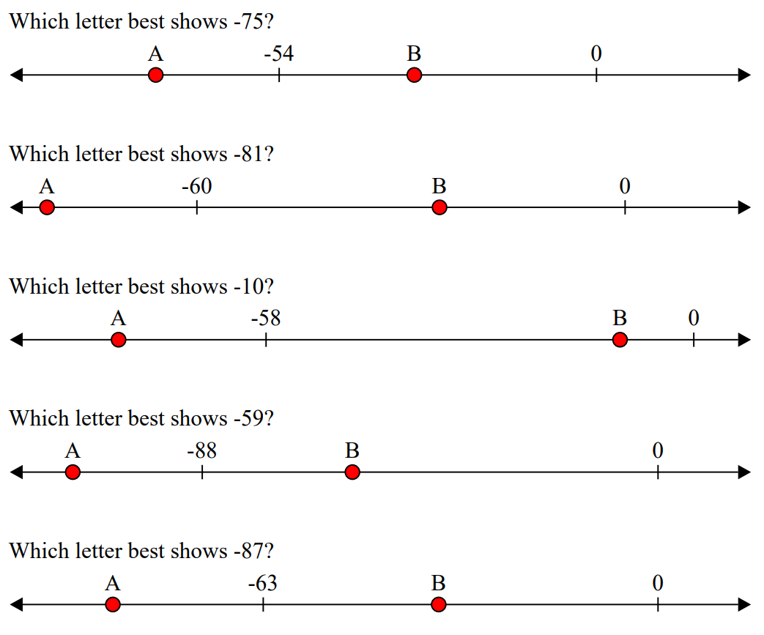
B
  - $-18$ ……
B
  - $-91$ ……
A
  - $-75$ ……
A
  - $-10$ ……
B
  - $-87$ ……
A
  - $-59$ ……
B

- Determine the value(s) the arrow is pointing to.
$$-50, 75$$ | 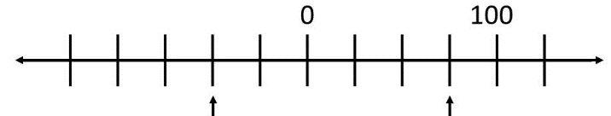  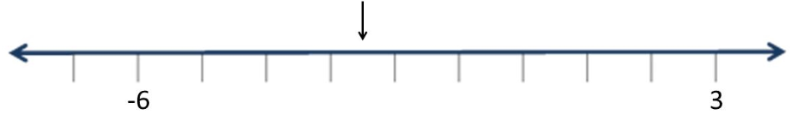  $$-2.5$$
$-0.2$ or $-\frac{1}{5}$ | 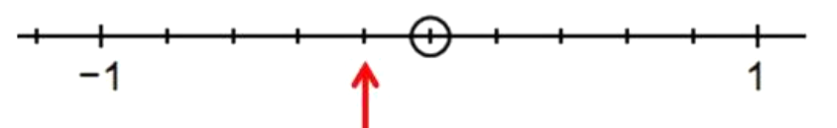  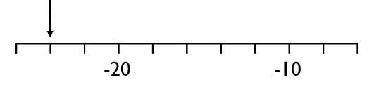  $$-24$$

- The distance from A to B is the same as the distance from B to C. Find the value of B.  $$-9$$ | - The distance from A to B is three times the distance from B to C. Find the value of B.  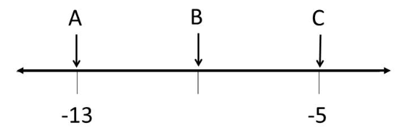  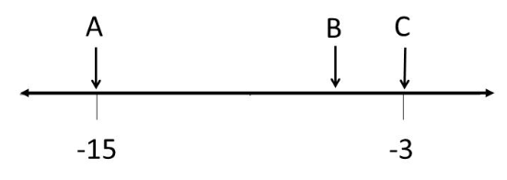  $$-6$$

Comparing and Ordering Integers

- Comparing Integers
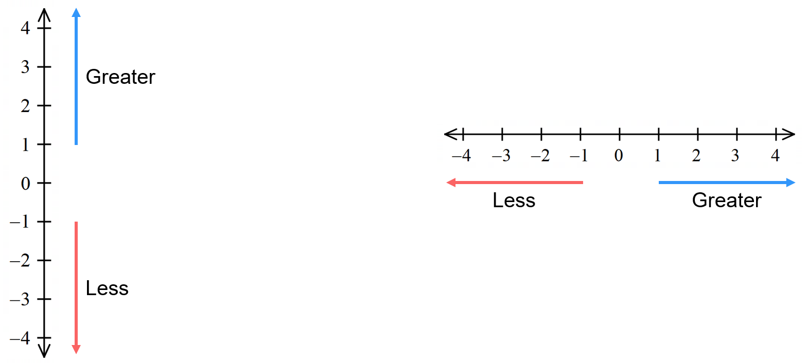
A number to the left, or below, on a number line is less.

A number to the right, or above, on a number line is greater.

- Compare integers
 | Circle the largest integer in each part.
 | - $2$, $-8$ | - $-1, 9$ | - $-3, -8$
 | - $7, -2$ | - $-3, -8, -6$ | - $0, -3, -10$
 | Choose the correct symbol ($<$or$>)$ to compare these integers.
 | - $2$ …… $-8$ | - $-3$ …… $-6$ | - $-6$ …… $-3$
 | - $4$ …… $-2$ | - $-3$ …… $50$ | - $0$ …… $-100$

Foundation
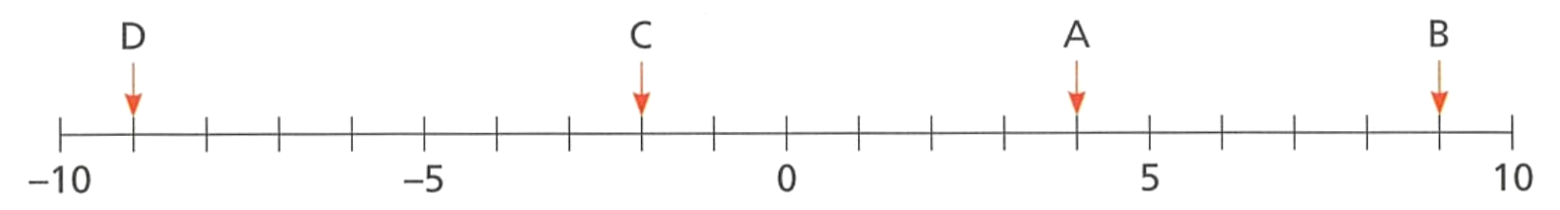
- What numbers are the arrows pointing to?

Order the numbers from smallest to largest. ……………………………………………………
$$-9, -2, 4, 9$$
- Use the number lines to compare these integers using the symbols $>$ and $<$
- $2$ …… $-3$  > | - $-8$ …… 3  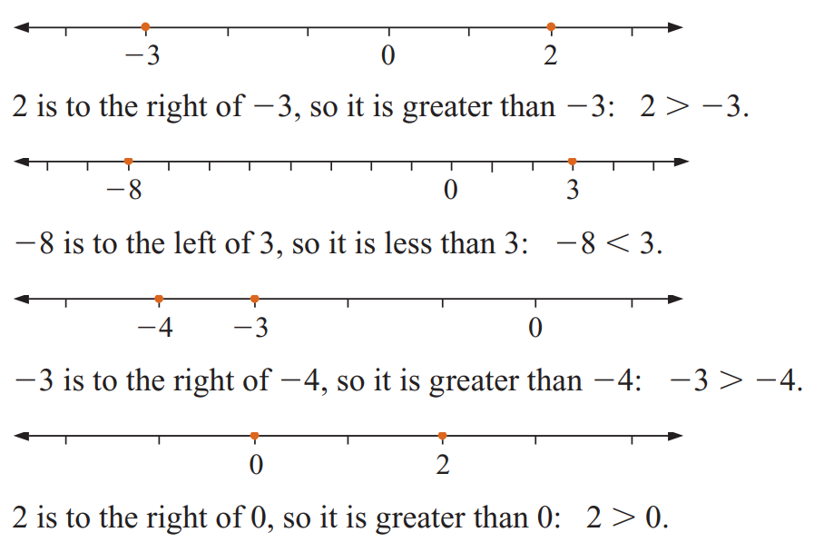  <
- $-3$ …… $-4$  >> | - $2$ …… $0$  >

- Complete the sentence by writing greater than or less than, then write using the > or < symbol.
a 3 is | …………………...  Greater | than 2 | 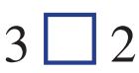  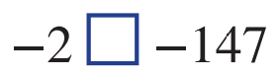  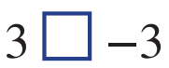  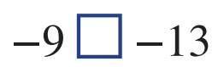  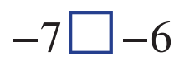  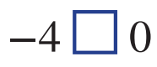  >
b $-4$ is | …………………...  Less | than 0 | <
c $-$7 is | …………………...  Less | than $-6$ | <
d $-$9 is | …………………...  Greater | than $-13$ | >
e $3$is | …………………...  Greater | than $-3$ | >
f $-$2 is | …………………...  Greater | than $-147$ | >

- Circle the body of water at the lowest altitude.
  - $-28$ m Caspian Sea
  - $-408$ m Dead Sea
  - $-15$ m Lake Eyre
B

Development
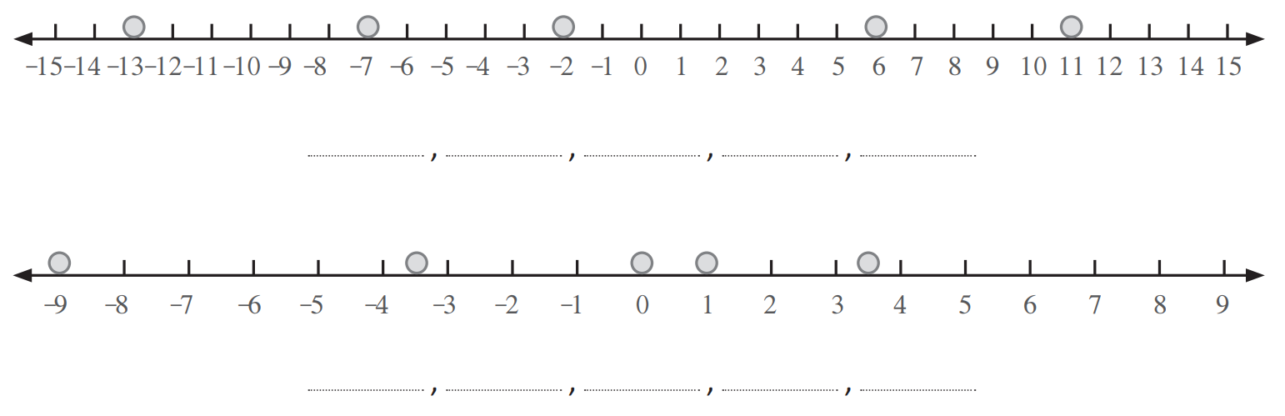
- List these numbers in ascending order.

$$-13, -7, -2, 6, 11$$

$$-9, -3.5, 0, 1, 3.5$$
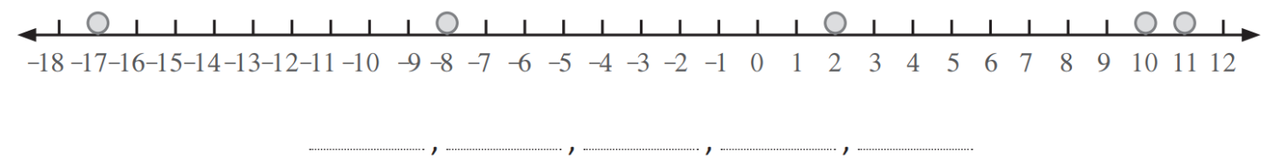

$$-17, -8, 2, 10, 11$$
- Compare these integers.
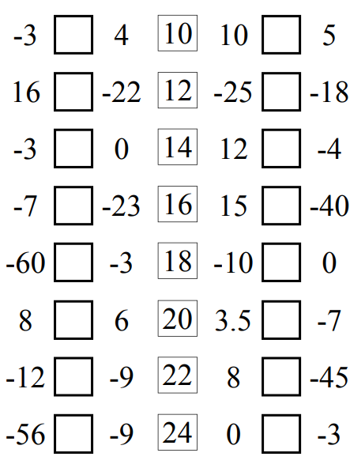  < | > | > | <
< | > | > | >
< | < | > | >
< | > | < | >

- Arrange these numbers in ascending order (smallest to largest).
  - −1, 8, −5, 2, −9, −4, 3 ………………………………………...…………
$$-9, -5, -4, -1, 2, 3, 8$$
  - 3, −5, 1, 0, −2, 4 ………………………………………...…………
$$-5, -2, 0, 1, 3, 4$$
  - −1, −7, −2, 5, −6, 1 ………………………………………...…………
$$-7, -6, -3, -1, 0, 1, 5$$
  - −3, −6, 0, 2, −10, 4, −1 ………………………………………...…………
$$-10, -6, -3, -1, 0, 2, 4$$
  - −30, 16, −12, −2, 1, 71, 0 ………………………………………...…………
$$-30, -12, -2, 0, 1, 16, 71$$
  - −11, −7, −6, −14, −8 ……………………………………………………
$$-14, -11, -8, -7, -6$$

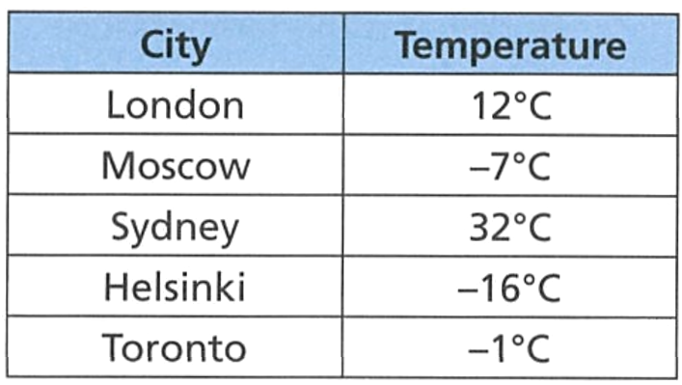
Mastery

  - Which city is the warmest?
Sydney
  - Which city is the coldest?
Helsinki
  - The temperature in Warsaw is warmer than Moscow but colder than Toronto. What is a possible temperature of Warsaw?

$$-6, -5, -4, -3, or-2°C$$
- Compare these integers.
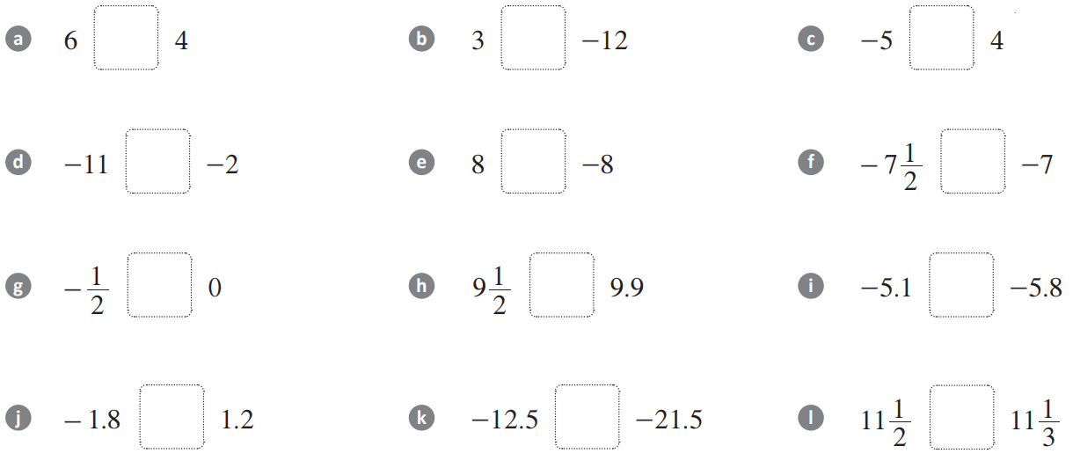  > | > | <
< | > | <
< | < | >

- An integer is greater than $-65$ and less than $-58$.
List all the possible integers in ascending order.
………………………………………………………………………………………………………………
$$-64, -63, -62, -61, -60,-59$$
- Put these numbers in ascending order.
  - $0.4, -0.3, -0.25, 0.35, 0.346$
…………………………………………………………………………………………………………
$$-0.3, -0.25, 0.346, 0.35, 0.4$$
  - $197.5, -109.4, -129.6, 14.5, 88.9$
…………………………………………………………………………………………………………
$$-129.6, -109.4, 14.5, 88.9, 197.5$$

Opposite Integers

- Opposite Integers
Opposite integers are two integers with the same magnitude but different directions.
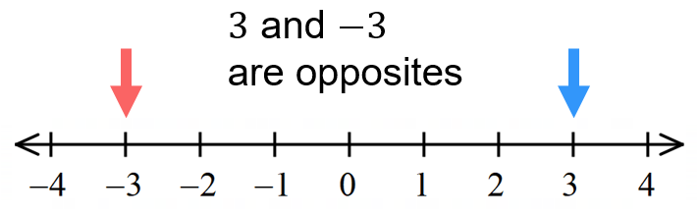

- Identify Opposite integers
Integer | Opposite |  | Integer | Opposite
$$4$$ |  |  |  | $$10$$
$$-4$$ |  |  |  | $$-10$$
$$+4$$ |  |  |  | $$74$$
$$92$$ |  |  |  | $$-81$$
$$-41$$ |  |  |  | $$71$$

- Additive Inverse
The sum of any integer and its opposite is zero.
$$a+\left(-a\right)=0$$
We call $a$and $-a$ a zero pair.

- Apply Additive inverse property
Find the missing integer:
- $5+\left(-5\right)=$ …… | - $3+$ …… $=0$ | - $-7+$ …… $=0$ | - …… $+(-4)=0$
- …… $+2=0$ | - $13+$ …… $=0$ | - $x+$ …… $=0$ | - $3+5+$ …... $=3$

- Key Ideas
- Opposite integers have the same ………………… but different …………………
- The ………… of an integer and its opposite is always 0.

The Negative Symbol

- Meaning of the Minus Sign
The minus symbol: $-$ has two different meanings in mathematics:
- Tells us that a number has negative direction, when it is ‘attached’ to a number.
$-5$ means ‘negative 5’
- To avoid confusion, we place negative numbers inside brackets to indicate that a negative is ‘attached’ to a number.

$8+\left(-5\right)$ means 8 add ‘negative 5’

- Tells us to subtract, when it is in between two numbers.
$8-5$ means ‘8 subtract 5’

- Interpret the negative symbol
$$10-4$$  10 subtract 4 | $$-7$$  negative 7 | $$5+\left(-2\right)$$  5 plus negative 2
$$-15+3$$  negative 15 add 3 | $$6-\left(-3\right)$$  6 subtract negative 3 | $$12-8$$  12 subtract 8
Write what these expressions mean.
- $9-4$ | - $-12$ | - $3+\left(-5\right)$
- $2-\left(-3\right)$ | - $7-2$ | - $-8-3$

Foundation
- Write what these expressions mean, using words.
- 5 − 3  5 subtract 3 | - −9  Negative 9
- 4 + (−7)  4 add negative 7 | - −2 + 6  Negative 2 add 6
- 11 − (−4)  11 subtract negative 4 | - −3 − 5  Negative 3 subtract 5
- −1 − (−8)  Negative 1 subtract negative 8 | - 0 − (−2)  0 subtract negative 2

- Write these as mathematical expressions.
- 7 subtract 2  $$7-2$$ | - Negative 6 subtract 1  $$-6-1$$
- Negative 4  $$-4$$ | - 10 subtract negative 5  $$10-\left(-5\right)$$
- 3 add negative 8  $$3+\left(-8\right)$$ | - The sum of negative 2 and negative 9  $$-2+\left(-9\right)$$

Adding and Subtracting Positive Integers

- Adding and Subtracting Positive Integers
To add a positive integer: move right on a number line.
To subtract a positive integer: move left on a number line.

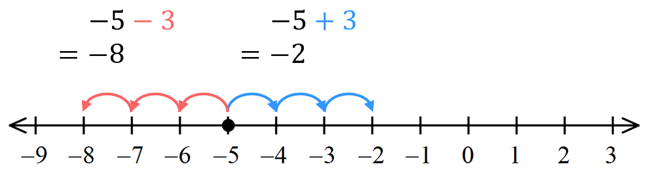

- Example Add and subtract positive integers
$-5+2$  $=-3$ | 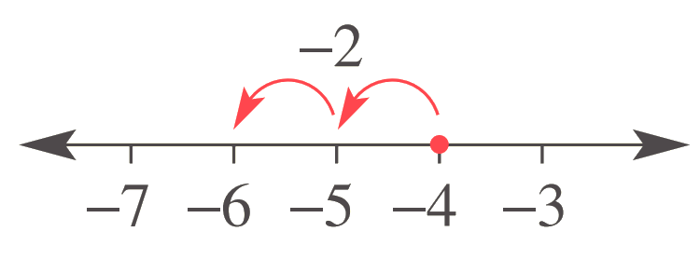  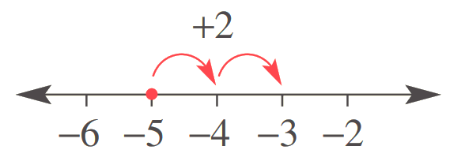  $-4-2$  $=-6$

- Guided Practice
Complete these calculations.
- $-2+3$  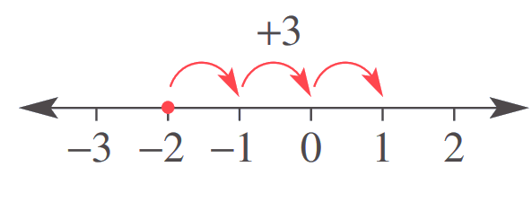  $=$  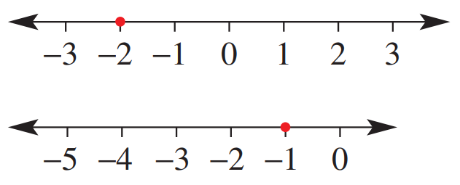 | - $-8+1$  $=$  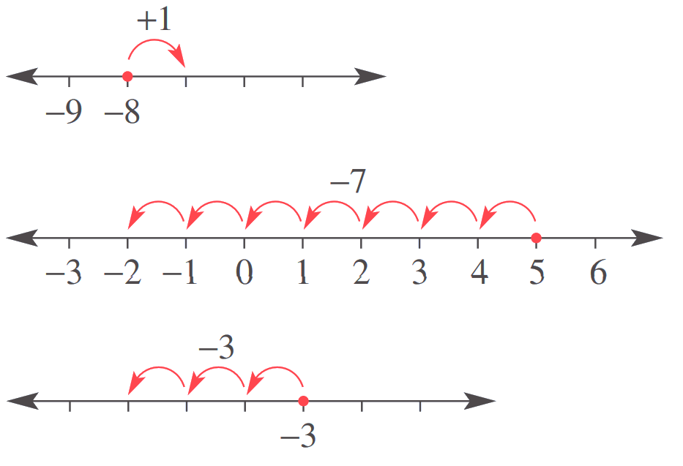
- $5-7$  $=$ | - $-3-3$  $=$
- $-2+6$  $=$ | - $-1-4$  $=$

Foundation
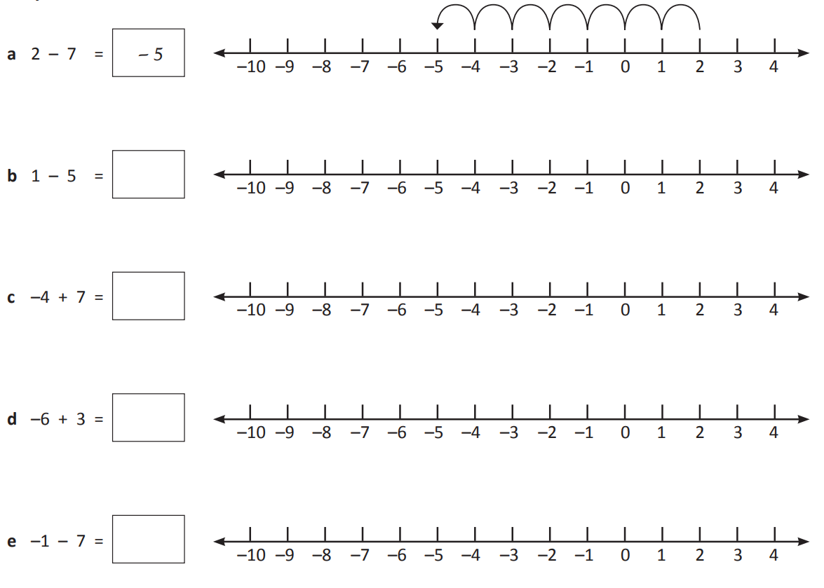
- Use the number lines to add and subtract these integers.

$$-4$$

$$-3$$

$$-3$$

$$-8$$

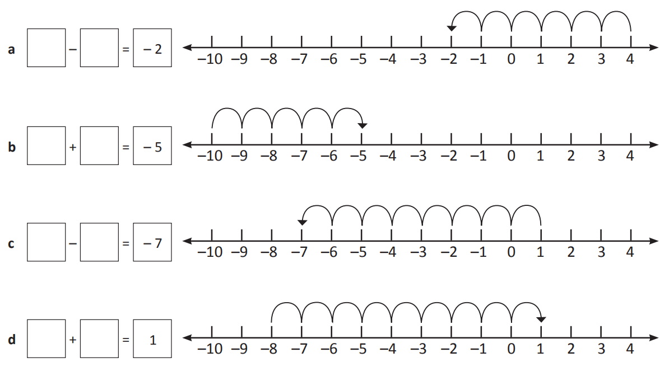
- Write the operation shown by the number lines.

$$4-6$$

$$-10+5$$

$$1-8$$

$$-8+9$$

- Solve each problem using the number line if needed.
  - $-3-9$

$$-12$$
  - $-11+7$

$$-4$$
  - $-15+11$

$$-4$$
  - $10-4$

6
  - $-2+5$

3
  - $-2+15$

13
  - $-3-9$

$$-12$$
  - $1-7$
$$-6$$
  - $-15+15$
0
  - $10-14$
$$-4$$

Development
- Use this number line to help you in the following questions.

a $-1+4=$  b $-10+11=$  c $-5+2=$  d $-8+0=$ | …………………  3  …………………  1  …………………  $$-3$$  …………………  $$-8$$ | e $7-8=$  f $1-10=$  g $-5-5=$  h $-7-0=$ | …………………  $$-1$$  …………………  $$-9$$  …………………  $$-10$$  …………………  $$-7$$

- Evaluate the answer to the following:

a 2 − 7 – 4 ……………………  ……………………  $$-9$$ | b −5 − 7 – 1 ……………………  ……………………  $$-13$$
c −1 − 4 + 6 ……………………  ……………………  1 | d −3 + 2 – 7 ....…………………  ……………………  $$-8$$

- Evaluate the following expressions.
- $-1+1$  $$0$$ | - $-3+2$  $$-1$$ | - $-10+9$  $$-1$$
- $-2+1$  $$-1$$ | - $-5+2$  $$-3$$ | - $-10+8$  $$-2$$
- $-3+1$  $$-2$$ | - $-10+2$  $$-8$$ | - $-10+7$  $$-3$$
- $-5+1$  $$-4$$ | - $-5+3$  $$-2$$ | - $-10+5$  $$-5$$
- $-10+1$  $$-9$$ | - $-5+4$  $$-1$$ | - $-20+1$  $$-19$$
- $-2+2$  $$0$$ | - $-5+5$  $$0$$ | - $-20+10$  $$-10$$

- Evaluate the following expressions.
- $-5-1$  $$-6$$ | - $-3-1$  $$-4$$ | - $-10-10$  $$-20$$
- $-5-2$  $$-7$$ | - $-3-4$  $$-7$$ | - $-10-11$  $$-21$$
- $-5-3$  $$-8$$ | - $-3-7$  $$-10$$ | - $-100-10$  $$-110$$
- $-3-5$  $$-8$$ | - $-3-10$  $$-13$$ | - $-100-11$  $$-111$$
- $-3-3$  $$-6$$ | - $-3-13$  $$-16$$ | - $-100-110$  $$-210$$
- $-3-2$  $$-5$$ | - $-3-15$  $$-18$$ | - $-100-1100$  $$-1200$$

- Evaluate the following expressions.
- $-5+6$  1 | - $-5+7$  2 | - $-5+9$  4
- $-3+4$  1 | - $-3+5$  2 | - $-3+7$  4
- $-4+5$  1 | - $-4+6$  2 | - $-4+8$  4
- $-2+3$  1 | - $-2+4$  2 | - $-2+6$  4
- $-2+2$  0 | - $-3+3$  0 | - $-4+4$  0
- $-5+6$  1 | - $-5+8$  3 | - $-5+9$  4

- Minh had a balance of $300 owing on his credit card. He recently paid off $120.
  - Explain why this scenario can be modelled by the expression $-300+120$
…………………………………………………………………………………………………………
Owing money is negative, so $-300$.
  - Find Minh’s new credit card balance. ……………………………………………………………
$$-180$$
- Todd enters the elevator at the carpark 4 floors below ground. He goes up 8 levels to his office.
Write an integer addition to find the level his office is at.
………………………………………………………………………………………………………………
4

- Calculate the answer without a number line.
- $6-9$  $$-3$$ | - $1-7$  $$-6$$ | - $4-8$  $$-4$$
- $8-9$  $$-1$$ | - $1-9$  $$-8$$ | - $5-7$  $$-2$$
- $5-8$  $$-3$$ | - $2-7$  $$-5$$ | - $5-8$  $$-3$$
- $5-6$  $$-1$$ | - $2-3$  $$-1$$ | - $7-8$  $$-1$$
- $7-8$  $$-1$$ | - $3-5$  $$-2$$ | - $5-10$  $$-5$$
- $6-8$  $$-2$$ | - $3-8$  $$-5$$ | - $3-17$  $$-14$$

- Circle the calculations that will have an answer less than 0.

$$2-8 \left| 3-5 \right|140-165 | 11-63$$
Explain your reasoning.
………………………………………………………………………………………………………………
………………………………………………………………………………………………………………
When subtracting a larger number from a smaller number, the answer will be negative.
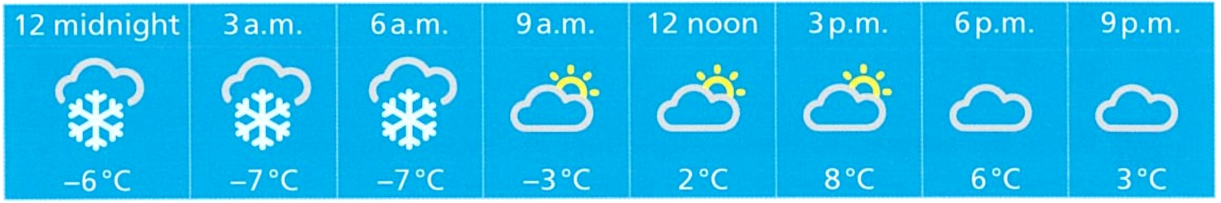
- The table shows the temperature in the Snowy Mountains at different times during one day.

  - By how many degrees does the temperature rise between midnight and noon? …………
8$°C$
  - By how many degrees does the temperature rise between 6 a.m. and noon? …………
9$°C$
  - Explain what happens to the temperature during the day.
…………………………………………………………………………………………………………
It gradually increases
  - The temperature falls by 6 degrees from 9 p.m. to 12 midnight the next day.
What is the temperature at 12 midnight on the next day?
…………………………………………………………………………………………………………
$3-6=-3°C$r

Mastery
- Fill in the missing number.
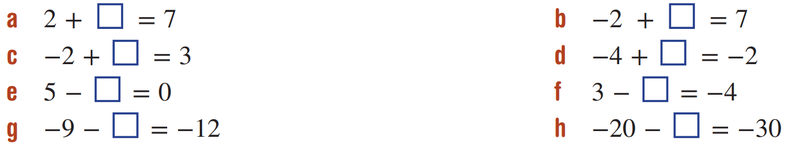  5 | 5 | 5 | 3
9 | 2 | 7 | 10

- Fill in the missing number.
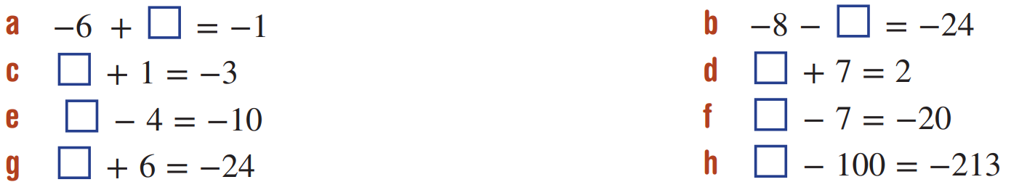  5 | $$-4$$ | $$-6$$ | $$-30$$
$$16$$ | $$-5$$ | $$-13$$ | $$-113$$

- Work out the missing numbers,
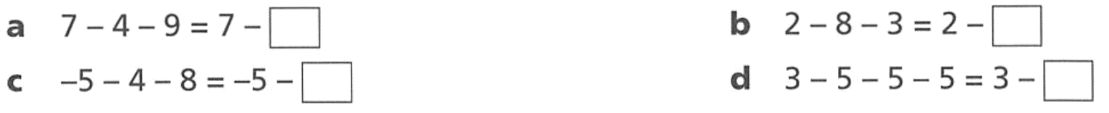  13 | 11
12 | 15

- Work out the missing numbers.
16 | 8 | 8 | 16
6 | $$-6$$ | 8 | $$-6$$

- Here is a number line.
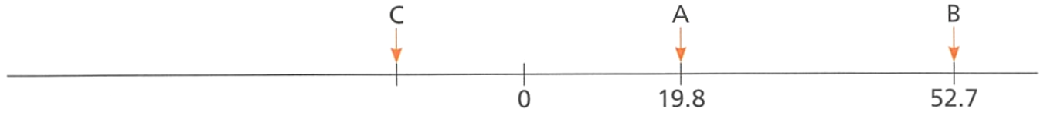

The difference between A and B is the same as the difference between C and A.
Find the value of C.

$$-13.1$$

Mental Shortcuts for Adding and Subtracting Integers

- Shortcuts for adding and subtracting integers
It is not practical to draw a number line when adding and subtracting large numbers.
Instead, we can use these two shortcuts:
Shortcut 1: when you have $-a-b:$
Subtracting from a negative makes it more negative.
$$-a-b=-\left(a+b\right)$$
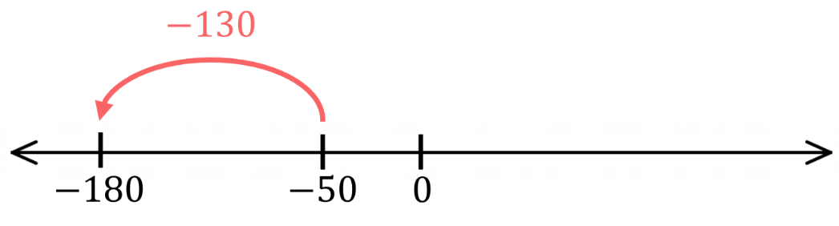
$$-50-130=-\left(50+130\right)$$
$=-180$

Shortcut 2: when you have $a-b$ or $-a+b$
Partition the integer with the larger magnitude to make zero pairs:
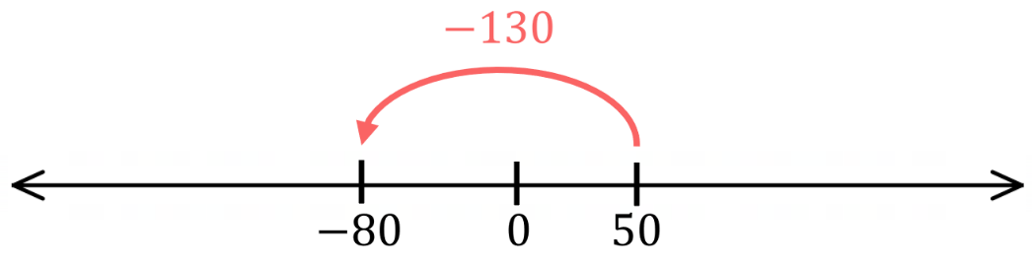
$$50-130=50-50-80$$
$=-80$
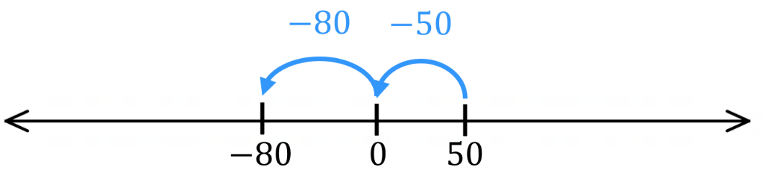

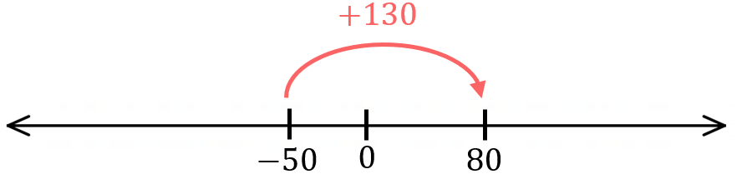
$$-50+130=-50+50+80$$
$=80$

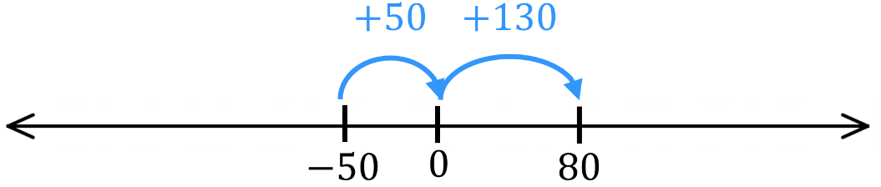

Foundation
- Complete each calculation.
- $-30 - 70 = -(30 + 70)$  $=$ $-$ ……………  $$-100$$ | - $-25 - 45 = -(25 + 45)$  $=$ ……………  $$-70$$
- $-120 - 80 = -$(………………)  $=$ ……………  $$-200$$ | - $-85 - 115 =$ ………………  $=$ ………………  $$-200$$

- Complete each calculation.
  - 40 − 110
= 40 − 40 − …………… (split 110 into 40 and ?)
= 0 − ……………
= ……………
$$-70$$
  - −60 + 150
= −60 + 60 + …………… (split 150 into 60 and ?)
= 0 + ……………
= ……………
90
  - 75 − 200
= 75 − …………… − ……………
= ……………
$$-125$$
  - −90 + 250
= −90 + …………… + ……………
= ……………
$$160$$
- Evaluate:
- $-45-55$  $$-100$$ | - $80-200$  $$-120$$
- $-70+180$  $$110$$ | - $-150-250$  $$-400$$
- $65-140$  $$-75$$ | - $-85+300$  $$215$$

Development

- $-75-125$  $$-200$$ | - $-35+120$  $$85$$
- $95-230$  $$-135$$ | - $-180-320$  $$-500$$
- $-145+400$  $$255$$ | - $160-425$  $$-265$$

- A diver is at −65 metres (below sea level). She descends another 48 metres.
What is her new depth?

$-65-48=-113$ m
113 m below sea level
- The temperature at midnight was −12°C. By noon, it had risen by 27°C.
What was the noon temperature?

$$-12+27=15°C$$
- A bank account has a balance of $85. After paying a bill of $220, what is the new balance?

$$85-220=-\$135$$
- Mr Ding owes $85 (this is $-\$85$). He borrows another $220. How much does he owe now?

$$-85-220=-\$305$$
He owes $305

Adding and Subtracting Negative Integers

- Adding and subtracting negative numbers
To work out a rule for questions where we are adding and subtract negative numbers,
like $3+\left(-12\right)$ and $3-\left(-12\right)$, we will look for a pattern and come up with a rule.
$3+2=$  $3+1=$  $3+0=$  $3+\left(-1\right)=$  $3+\left(-2\right)=$  $3+\left(-12\right)=$ | $(-3)+2=$  $(-3)+1=$  $(-3)+0=$  $(-3)+\left(-1\right)=$  $(-3)+\left(-2\right)=$  $(-3)+\left(-12\right)=$
$3-2=$  $3-1=$  $3-0=$  $3-\left(-1\right)=$  $3-\left(-2\right)=$  $3-\left(-12\right)=$ | $\left(-3\right)-2=$  $\left(-3\right)-1=$  $\left(-3\right)-0=$  $\left(-3\right)-\left(-1\right)=$  $\left(-3\right)-\left(-2\right)=$  $\left(-3\right)-\left(-12\right)=$

- Rewriting Touching Signs
Adding a negative number is the same as subtracting the positive.
$$a+\left(-b\right)=a-b$$
Subtracting a negative number is the same as adding the positive.
$$a-\left(-b\right)=a+b$$

- Rewrite Touching signs as a single sign
$$5+\left(-6\right)$$  $$=5-6$$ | $$5-\left(-6\right)$$  $$=5+6$$ | $$-5+\left(-2\right)$$  $$=-5-2$$
Rewrite these touching signs as a single calculation
- $2+(-3)$ | - $10+(-1)$ | - $-5-(-3)$
- $-6-(-2)$ | - $5+(-1)$ | - $-6+(-2)$

- Key Ideas
- $a+\left(-b\right)=$ ………………
- $a-\left(-b\right)=$ ………………
- When you see two touching signs, if they are the same, rewrite as …………………, if they are different, rewrite as …………………

Foundation
- Rewrite these as subtraction. Do not evaluate the answer.
- $28+(-76)$  $=28-76$ | - $-28+(-76)$  $$-28-76$$ | - $76+(-28)$  $$76-28$$ | - $18+(-76)$  $$18-76$$
- $-18+(-76)$  $$-18-76$$ | - $76+(-18)$  $$76-18$$ | - $-76+(-18)$  $$-76-18$$ | - $-77+(-19)$  $$-77-19$$

- Rewrite these as addition. Do not evaluate the answer.
- $5-(-3)$  $=5+3$ | - $-5-(-3)$  $$-5+3$$ | - $3-(-5)$  $$3+5$$ | - $-3-(-5)$  $$-3+5$$

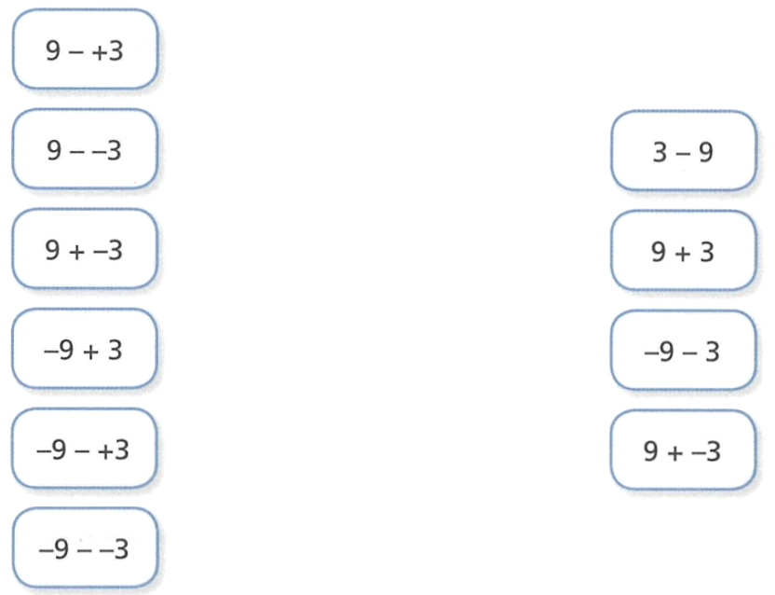
- Match the calculation on the left with a calculation on the right.

- Fill in the table. If you see a single sign, rewrite as two signs.
Calculation | Rewritten |  | Calculation | Rewritten
- $5-2$ | $$5+(-2)$$ |  | - $4+(-3)$ | $$4-3$$
- $4-3$ | $$4+\left(-3\right)$$ |  | - $\left(-5\right)+3$ | $$-5-\left(-3\right)$$
- $3-\left(-2\right)$ | $$3+2$$ |  | - $-2+1$ | $$-2-\left(-1\right)$$
- $2-\left(-4\right)$ | $$2+4$$ |  | - $3+(-4)$ | $$3-4$$
- $(-3)-5$ | $$(-3)+(-5)$$ |  | - $2+(-5)$ | $$2-5$$
- $\left(-2\right)-3$ | $$\left(-2\right)+\left(-3\right)$$ |  | - $(-3)+4$ | $$-3-\left(-4\right)$$
- $\left(-4\right)-2$ | $$-4+\left(-2\right)$$ |  | - $\left(-2\right)-(-1)$ | $$-2+1$$
- $5+(-2)$ | $$5-2$$ |  | - $\left(-3\right)-(-4)$ | $$-3+4$$
- Adding and Subtracting Integers
- If you see two touching $+$ or $-$ signs:
  - Different signs, rewrite as subtraction. $-5+\left(-3\right)=-5-3$
  - Same signs, rewrite as addition. $-5-\left(-3\right)=-5+3$

- Adding and subtracting positive integers:
  - To add positive integers, move right on a number line. $-5+3=2$
  - To subtract positive integers, move left on a number line. $-5-3=-8$

- Example Add and subtract negative integers
$-2+\left(-3\right)$  1. $=-2-3$  2. $=-5$ | When the touching signs are ………………, we rewrite as subtraction.
$-6-(-2)$  1. $=-6+2$  2. $=-4$ | When the touching signs are ………………, we rewrite as addition.

- Guided Practice
- $2+\left(-3\right)=2$ …… $3$  $=$ ……… | - $-7-\left(-3\right)=$ ………  $=$ ………
- $10+\left(-12\right)=$ ………  $=$ ……… | - $-5-\left(-3\right)=$ ………  $=$ ………

- Key Ideas
- When you see two touching signs, always write them as a ……………… sign.

Foundation
- Complete the following
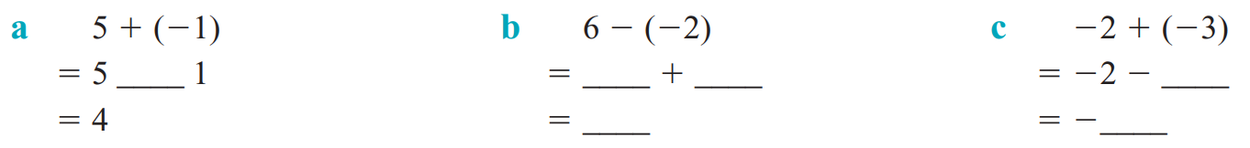 | 8 | $$-5$$
- Rewrite these questions with a single plus or minus symbol and calculate the answer.
- $5+\left(+1\right)$  $=5+1$  $=$ …………  6 | - $1-\left(-5\right)$  6 | - $1+\left(+5\right)$  6
- $5-\left(-1\right)$  6 | - $4+\left(+5\right)$  9 | - $5+\left(+4\right)$  9
- $5+\left(+3\right)$  8 | - $3+\left(+5\right)$  8 | - $3-\left(-5\right)$  8
- $5-\left(-3\right)$  8 | - $3-\left(-3\right)$  6 | - $3+\left(+3\right)$  6
- $3-\left(-9\right)$  12 | - $3+\left(+19\right)$  22 | - $3+\left(+29\right)$  32
- $3-\left(-29\right)$  32 | - $3-\left(-99\right)$  102 | - $3+\left(+99\right)$  102

- Rewrite these questions with a single plus or minus symbol and calculate the answer.
- $8+\left(-4\right)$  $=8-4$  $=$ …………  4 | - $8+\left(-3\right)$  5 | - $8-\left(+3\right)$  5
- $8-\left(+1\right)$  7 | - $8-\left(+5\right)$  3 | - $8+\left(-2\right)$  6
- $5+\left(-2\right)$  3 | - $5-\left(+2\right)$  3 | - $5-\left(+5\right)$  0

Development
- Rewrite these questions with a single plus or minus symbol, then calculate the answer.
- 8 + (−3)  $=8-3$  $=$ …………  5 | - 9 + (−7)  2 | - 6 + (−11)  $$-5$$
- 0 + (−4)  $$-4$$ | - 0 + (−6)  $$-6$$ | - −7 + (−15)  $$-22$$
- −28 + (−10)  $$-38$$ | - −20 + (−9)  $$-29$$ | - −13 + (−9)  $$-22$$
- 5 − (−6)  $$11$$ | - 23 − (−11)  34 | - −7 − (−4)  $$-3$$
- −41 − (−7)  $$-34$$ | - −9 − (−10)  1 | - −9−(−14)  5
- 28 − (−6)  $$34$$ | - −14−(−28)  14 | - −9−(−9)  0

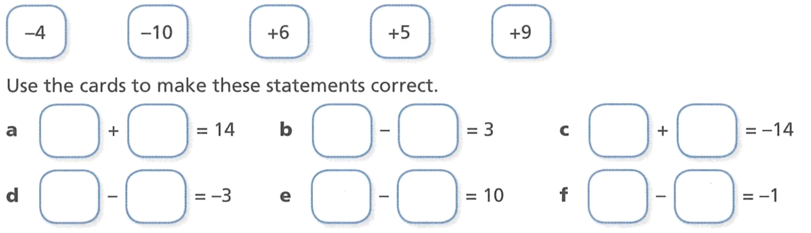
- Here are some number cards.

Use the cards to make these equations correct. You may reuse the cards.
+9, +5 | +9, +6 | –10, –4
+6, +9 | 6,–4 | +5, +6

- Here are some number and symbol cards.

Use three of the cards to make a calculation with an answer of 4. Find two different ways.
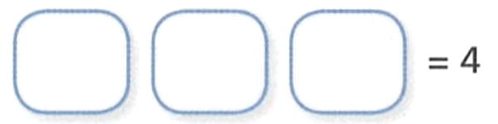

–2 – –6 or +7 – +3,
other combinations may be possible.
- Work out the missing numbers.
7  –7 | –5  5 | 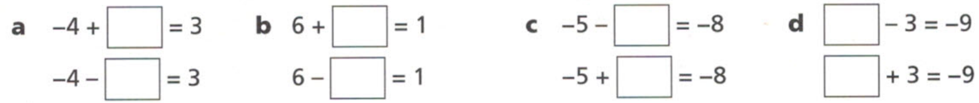  3  –3 | –6  –12

- Model each situation with a number sentence, then calculate the final position.
- From ground level, a lift went down 2 floors, then down another 3 floors.  $$-5$$ | - From ground level, a lift went down 3 floors, then up 5 floors, then down 4 floors.  $$-2$$
- An Olympian dived 5 metres from a board 3 metres above water level.  What is her position now?  $$-2$$ | - A submarine at sea level dived 50 metres, then dived another 26 m, then rose 32 metres.  $$-44$$
- In Norway the highest recorded temperature is 35°C and the lowest is $-26$°C. What is the difference between temperatures?  61 | - The lowest point in Japan is Lake Hachirogata at $-4$ m and the highest point is Mt Fujiyama at 3776 m.  What is the height difference?  3780 m

Mastery
- Find the missing number
a  –10 | 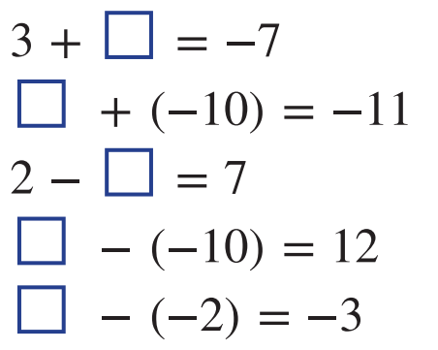  b  –1
c  –5 | d  2
e  –5 |   f  4

- Find the missing numbers.
9 | 8 | 4
13 | 11 | 14

- Find the missing numbers.
–3 | 3 | –3 | 3
–8 | 8 | 8 | –8

- Complete the following.
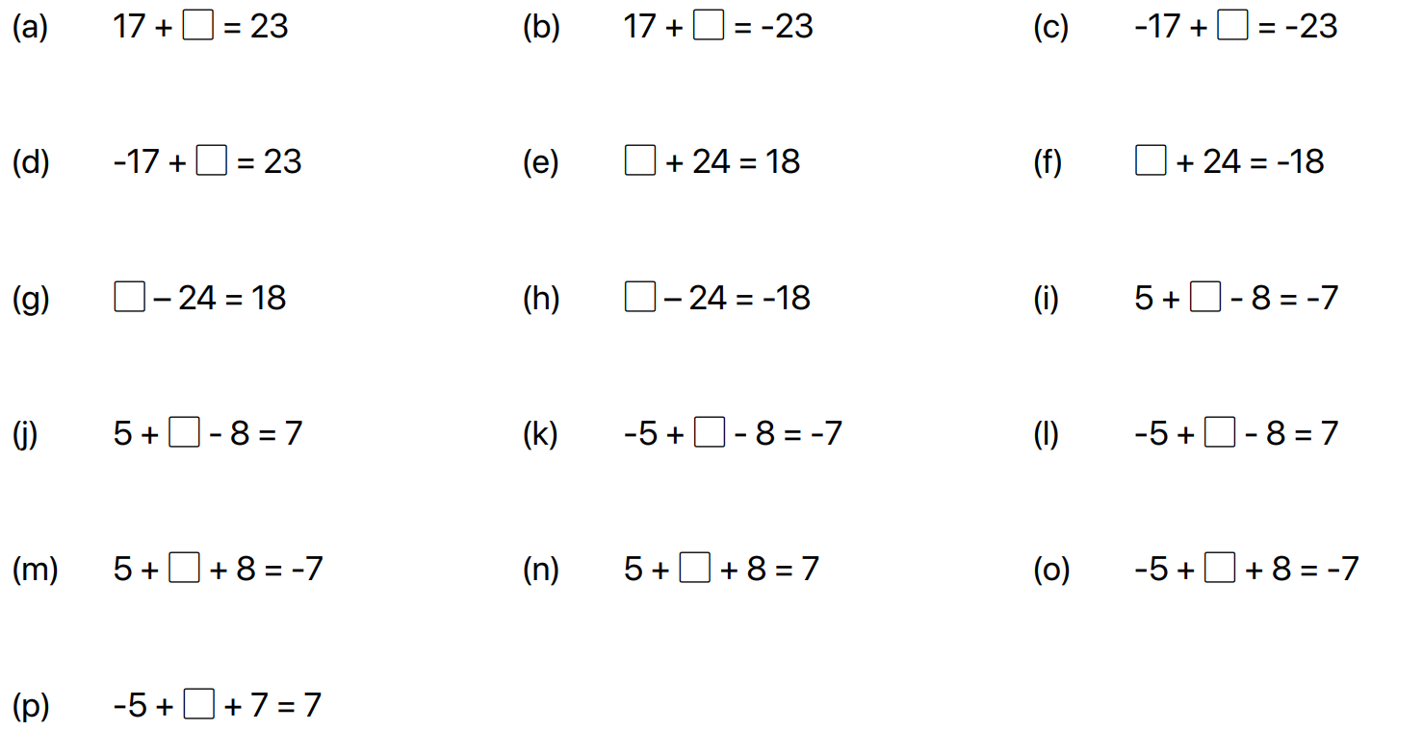  6 | –40 | –6
40 | –6 | –42
42 | 6 | –4
10 | 6 | 20
–20 | –6 | –10

- You owe $350 to your older sister. You recently earned $420 and paid back the debt.
By writing an integer addition, find how much money you have left.
………………………………………………………………………………………………………………
$$-350+420=70$$
- A sample of liquid helium has a temperature of $-300°C$.
The temperature needs to increase by $31°C$ to turn into gas. Find this temperature.
.………………………………………………………………………………………………………………
$$-300+31=-269$$
- Determine how much debt remains in these financial situations.
  - Mr Ding owes the bank $450 and pays back $400.
$\left(-450\right)+400=$ ……………………………………………………………………………………
$$-\$50$$
  - Mr Ding owes $20 and borrows another $35
…………………………………………………………………………………………………………
$$-\$55$$
  - Mr Ding owes $21500 and pays back $16250
…………………………………………………………………………………………………………
$$-\$5250$$
- An ocean sensor is raised and lowered to different depths in the sea.
Note that −100 metres means 100 metres below sea level.
  - If the sensor is initially at −100 metres and then raised by 41 metres,
what is its new position?
…………………………………………………………………………………………………………
$$-59$$
  - If the sensor is initially at −37 metres and then lowered another 60 metres,
what is its new position?
…………………………………………………………………………………………………………
$$-97$$
- NAPLAN C
Murray lives in Bundaberg where the temperature on a particular day was 39°C.
Murray's son lives in Salt Lake City and on the same day the temperature there was −15°C. What was the temperature difference between the two towns on this day?

54$°C$

- NAPLAN B+
Death Valley is the lowest point in the United States at −85 metres, which is below sea level. King's Peak, also in the United States, is 4128 metres above sea level.
What is the difference, in metres, between Death Valley and King's Peak?

4213 m
- Complete these magic squares.
The columns, rows, and diagonals must sum to the same number.
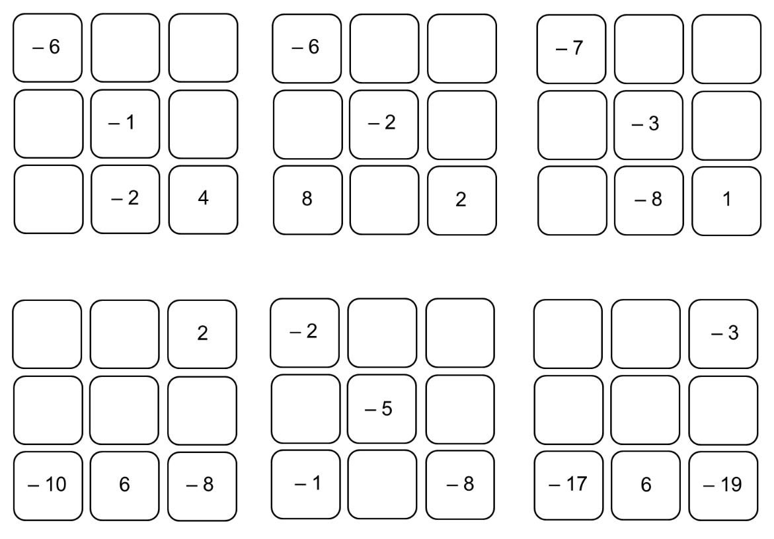  0, 3  8, –10  –5 | 12, –12  –8, 4  –16 | $-1$, $-26$  $-12$, $-10$, $-8$

- Find two numbers which have:
  - a sum of –2 and a difference of 8.
3, –5
  - a sum of –6 and a difference of 12.
–9, 3
  - a sum of 0 and a difference of 16.
8, –8
  - a sum of –8 and a difference of 2.
–3, –5
- NAPLAN A
James runs a tyre fitting company.
At the beginning of February he took out a $50 000 loan to expand his workshop.
In July James had flood damage in his workshop and added $20 000 to his bank loan to pay for repairs.
By the end September he had made loan repayments totalling $12 000 and had also deposited business profits of $15 000 into his loan account.
Write a number sentence and use it to calculate how much James owed at the end of September.

–43 000

Multiplying and Dividing Integers

- Sign rules for multiplication and division
We will investigate the sign rules for multiplying integers:
$3×2=$  $3×1=$  $3×0=$  $3×\left(-1\right)=$  $3×\left(-2\right)=$  $3×\left(-7\right)=$ | $(-3)×2=$  $(-3)×1=$  $(-3)×0=$  $(-3)×\left(-1\right)=$  $(-3)×\left(-2\right)=$  $(-3)×\left(-7\right)=$

- Sign Rules for Multiplication and Division
Same signs $→$ positive
When multiplying/dividing two numbers with the same sign (both positive or both negative), the answer is positive.

Different signs $→$ negative
When multiplying/dividing two numbers with different signs (one positive, one negative), the answer is negative.

- Identify Whether the answer will be positive or negative
negative $×$ negative  = positive | positive $×$ negative  = negative | positive $÷$ negative  = negative
Decide whether the answer will be positive or negative.
- negative $×$ positive  - Positive  - Negative | - negative $×$ positive  - Positive  - Negative | - positive $×$ positive  - Positive  - Negative
- positive $÷$ negative  - Positive  - Negative | - negative $÷$ negative  - Positive  - Negative | - negative $×$ negative  - Positive  - Negative
- Multiplying and Dividing Integers
When multiplying integers, we work out the sign separately from the magnitude.

- Determine the sign of the answer
Same signs $→$ positive
Different signs $→$ negative

- Multiply the magnitudes, ignoring the signs.

- Write the correct sign with the magnitude.

- Example Multiply and divide integers
$$5×\left(-6\right)$$  1. answer is negative  2. $5×6=30$  3. $5×\left(-6\right)=-30$ | $-18÷\left(-9\right)$  1. answer is positive  2. $18÷9=2$  3. $-18÷\left(-9\right)=2$

- Guided Practice
Evaluate the following:
- $3×\left(-5\right)$ | - $-8÷\left(-4\right)$
- $-2×\left(-14\right)$ | - $14÷\left(-7\right)$
- $6×\left(-11\right)$ | - $-36÷\left(-3\right)$

- Key Ideas
- When multiplying or dividing two numbers with …………………, the answer is positive.
- When multiplying or dividing two numbers with …………………, the answer is negative.

Foundation
- Fill in the missing numbers, using the pattern.
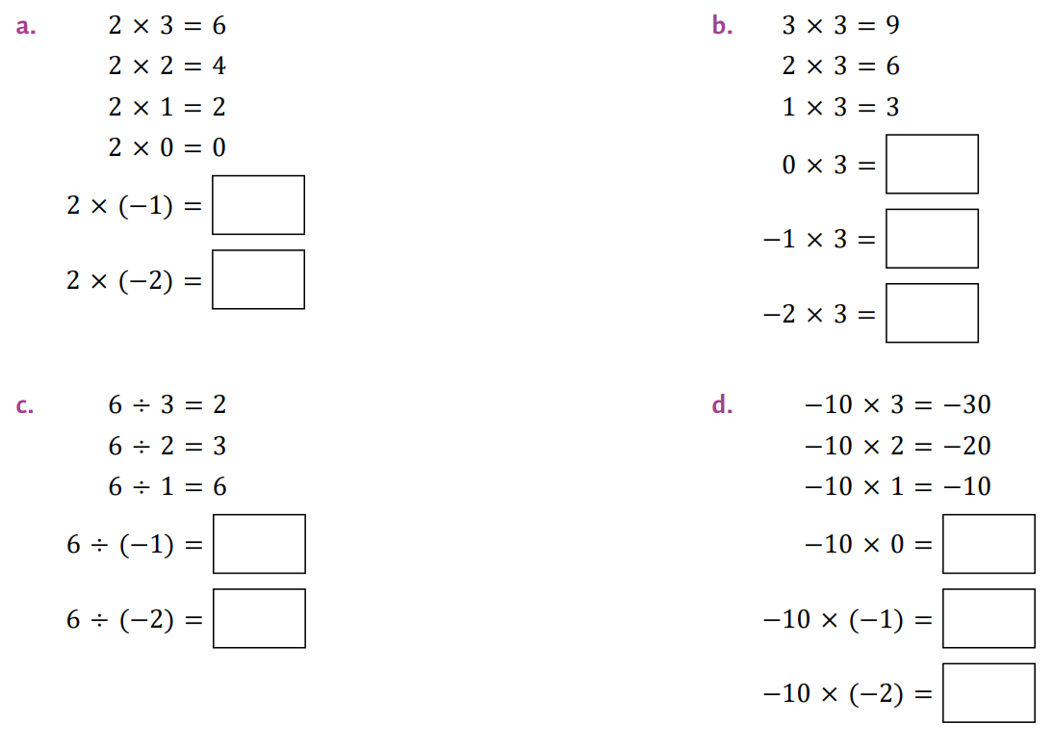  $$-2, -4$$ | $$0, -3, -6$$ | $$-6, -3$$ | $$0, 10, 20$$
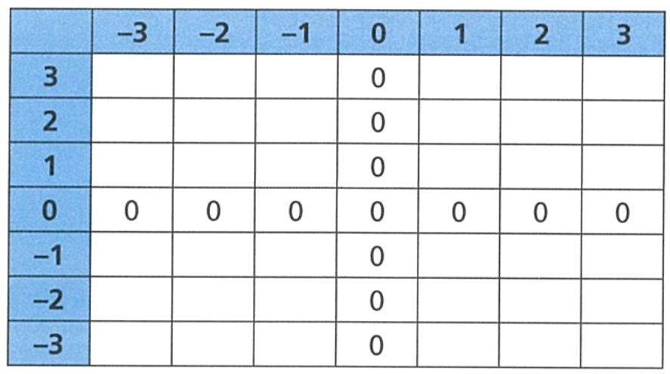
- Fill in the multiplication table.
What patterns do you notice?
……………………………………………
……………………………………………
……………………………………………
……………………………………………

Negative $×$ Positive = Negative; Negative $×$ Negative = Positive; Positive $×$ Positive = Positive
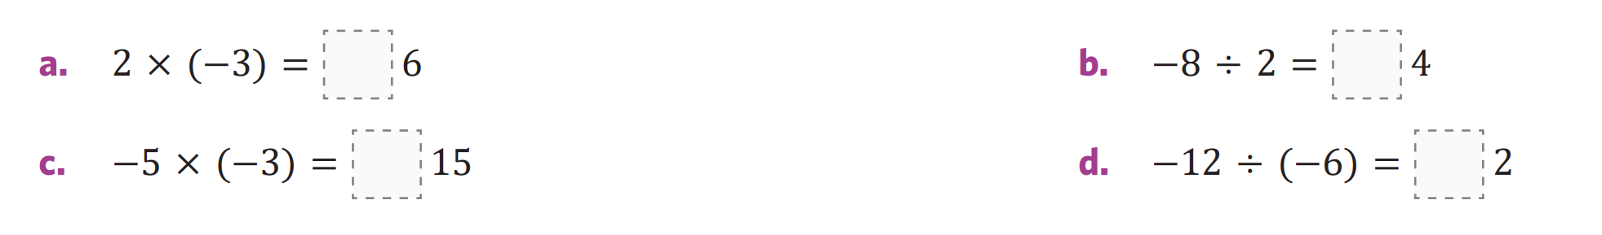
- Show the direction of each result by placing a negative or positive sign in the empty boxes.
$$-$$ | $$-$$ | $$+$$ | $$+$$

- Write down the missing number.
15, 3 | $-15$, $-3$
$-15$, $-3$ | $15$ , $-3$

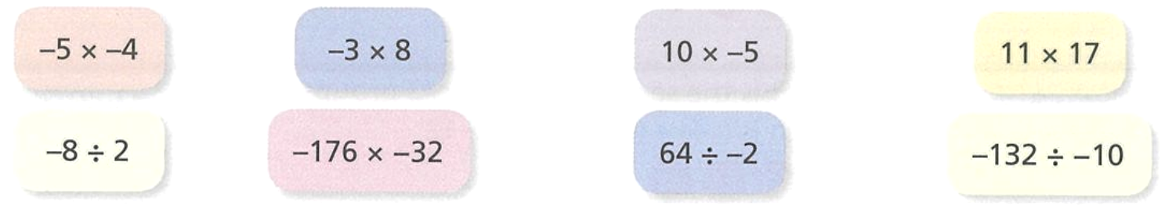
- Sort these calculations into two groups.

Calculations with a positive answer  $$-5×-4 \left| 11×17 \right|-176×-32 | -132÷-10$$ | Calculations with a negative answer  $$-3×8 \left| 10×-5 \right|-8÷2 | 64÷-2$$

- Calculate the answer to the following
- $2×10$  20 | - $\left(-10\right)÷(-2)$  5 | - $10×2×(-2)$  $$-40$$
- $10×2$  20 | - $\left(-10\right)÷(-2)$  5 | - $10×\left(-2\right)×(-2)$  40
- $\left(-10\right)×2$  $$-20$$ | - $10÷(-2)$  $$-5$$ | - $\left(-10\right)×\left(-2\right)×(-2)$  $$-40$$
- $10×(-2)$  $$-20$$ | - $\left(-10\right)÷2$  $$-5$$ | - $\left(-10\right)÷\left(-2\right)×(-2)$  $$-10$$
- $\left(-10\right)×(-2)$  20 | - $10×2×2$  40 | - $10×\left(-2\right)÷(-2)$  10

- Calculate the answer to the following.
- $1×(-10)$  $$-10$$ | - $-4×6$  $$-24$$ | - $-2×(-14)$  $$28$$
- $-11×9$  $$-99$$ | - $-7×(-11)$  $$77$$ | - $36÷(-3)$  $$-12$$
- $5×(-9)$  $$-45$$ | - $-36×(-2)$  $$72$$ | - $-100÷25$  $$-4$$
- $-19÷(-19)$  $$1$$ | - $38÷(-2)$  $$-19$$ | - $-108÷9$  $$-12$$
- $78÷(-6)$  $$-13$$ | - $-12÷(-12)$  $$1$$ | - $3×(-5)$  $$-15$$

Development
- Fill in the missing numbers.
$-$8 | $$-6$$ | 12 | $$-8$$
$$-32$$ | $$-32$$ | 32 | $$8$$

- Fill in the missing numbers.
$$-4$$ | $$4$$ | $$-4$$
$$-28$$ | $$28$$ | $$-28$$

- Fill in the missing numbers.
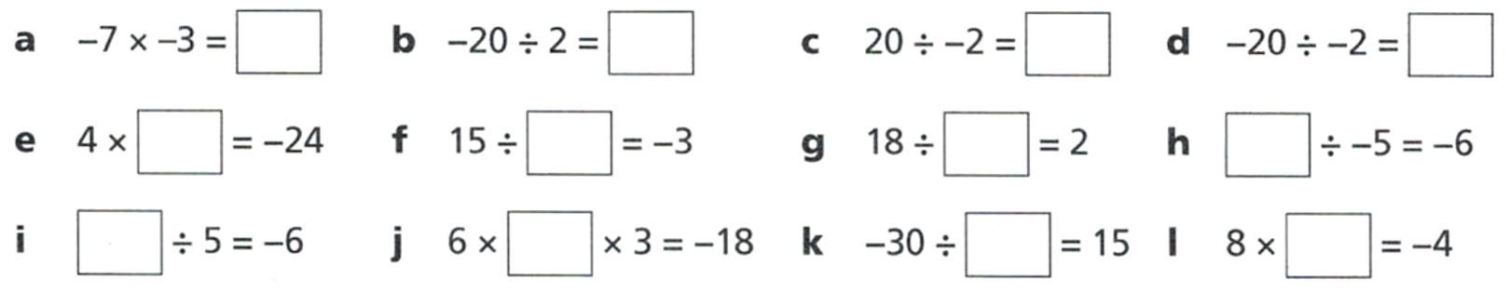  21 | $$-10$$ | $$-10$$ | 10
$$-6$$ | $$-5$$ | 9 | 30
$$-30$$ | $$-1$$ | $$-2$$ | $$-0.5$$

- Complete these multiplication tables.
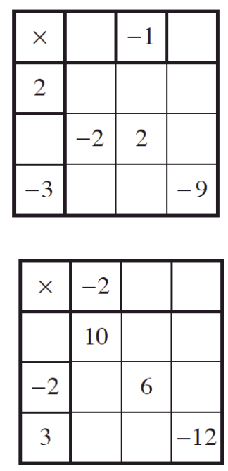  1 3  2 $-2$ 6  $-2$ $-6$  $-3$ 3 | $-3$ $-4$  $-5$ 15 20  $4$ 8  $-6$ $-9$

- Use these numbers to complete these calculations.

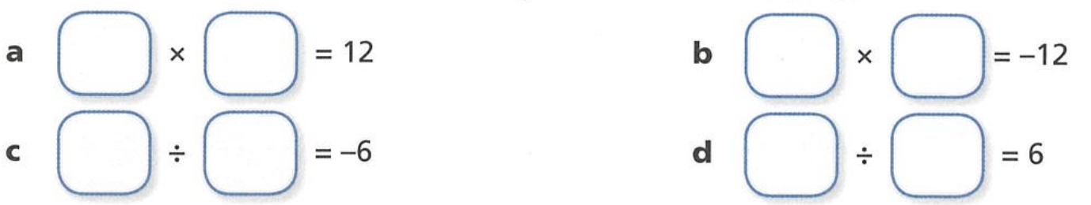

$3×4$ $12×-1$

$-24÷4$ $-24÷-4$
Other answers possible.
- Write down the missing number in these calculations.
a  4 | 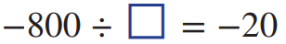  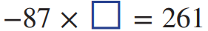  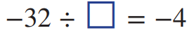  b  8
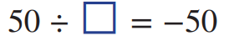  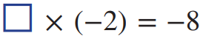    c  $$-140$$ | d  $$-3$$
e  $$-1$$ | f  40

- Here are some number cards

Choose cards to make these statements correct. Find at least two different ways.

- Calculate the following. Since multiplication and division have equal priority, perform operations from left to right.
- $2×\left(-3\right)×\left(-4\right)$  24 | - $-10÷5×2$  $$-4$$ | - $-15÷\left(-3\right)×1$  5
- $-2×7÷\left(-14\right)$  1 | - $48÷\left(-2\right)×\left(-3\right)$  72 | - $-36×2÷(-4)$  18
- $-8÷\left(-8\right)÷\left(-1\right)$  $$-1$$ | - $46÷\left(-2\right)×\left(-3\right)×\left(-1\right)$  $$-69$$ | - $-108÷\left(-12\right)÷(-3)$  $$-3$$

- Fractions mean to divide. $\frac{9}{3}$ $=9÷3$. Evaluate the following:
$$\frac{-12}{4}$$  $$-3$$ | $$\frac{12}{-4}$$  $$-3$$ | $$-\frac{12}{4}$$  $$-3$$ | $$\frac{-12}{-4}$$  $$3$$
$$\frac{21}{-7}$$  $$-3$$ | $$\frac{-40}{-5}$$  $$8$$ | $$\frac{-124}{4}$$  $$-31$$ | $$\frac{-100}{20}$$  $$-5$$

Mastery
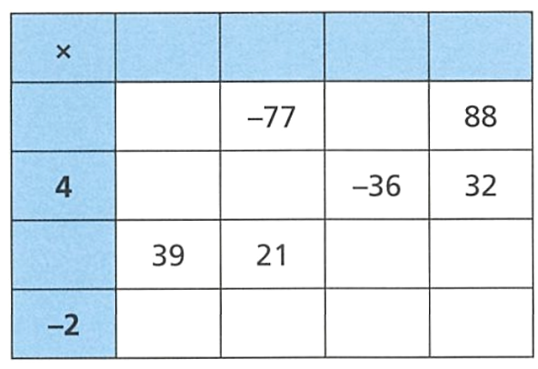
- Fill in the multiplication table.

$$-13 -7 -9 8$$
11 $-143$ $-99$
$$-52 -28$$
$$-3 27 -24$$
$$26 14 18 -16$$

- Squaring a number means to multiply it by itself: 3² = 3 × 3 and (−3)² = −3 × (−3).
Calculate each of these and make a conclusion.
a ${\left(-2\right)}^{2}=$ | 4 | b ${\left(-9\right)}^{2}=$ | 81
c ${\left(-10\right)}^{2}=$ | 100 | d ${\left(-1.1\right)}^{2}=$ | 1.21
When you square a number, the answer is always p……………
positive
- $2^{4}$ means repeated multiplication: $2×2×2×2$, and ${\left(-2\right)}^{4}$ means $\left(-2\right)×\left(-2\right)×\left(-2\right)×(-2)$.
Calculate:
- ${\left(-2\right)}^{3}$  $$-8$$ | - ${\left(-2\right)}^{6}$  64 | - ${\left(-3\right)}^{3}$  $$-27$$ | - ${\left(-3\right)}^{4}$  81
When you multiply a negative number an even number of times, the answer is ………………….
positive
When you multiply a negative number an odd number of times, the answer is ……………………
negative
Determine whether the answer to these questions will be positive or negative.
- ${\left(-65\right)}^{13}$  negative | - ${\left(52\right)}^{7}$  positive | - ${\left(-43\right)}^{300}$  positive | - ${\left(-2413\right)}^{14}$  positive

- Find the two integers that:
  - Have a product of $-30$ and a sum of $-1$.
$$-6, 5$$
  - Have a product of $20$ and a sum of $-12$.
$$-10, -2$$
  - Have a product of $18$ and a sum of $-11$.
$$-2, -9$$
  - Have a product of $-84$ and a sum of $-5$.
$$7, -12$$
  - Have a product of $-44$ and a sum of $7$.
$$-4, 11$$

Mixed Practice

Foundation
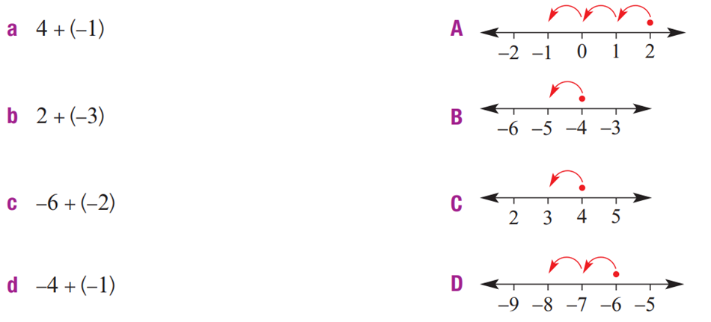
- Match up the problems (a to d) with the number lines (A to D).

a – C, b – A, c – D, d – B
- Match each subtraction (a to d) with the correct diagram (A to D)
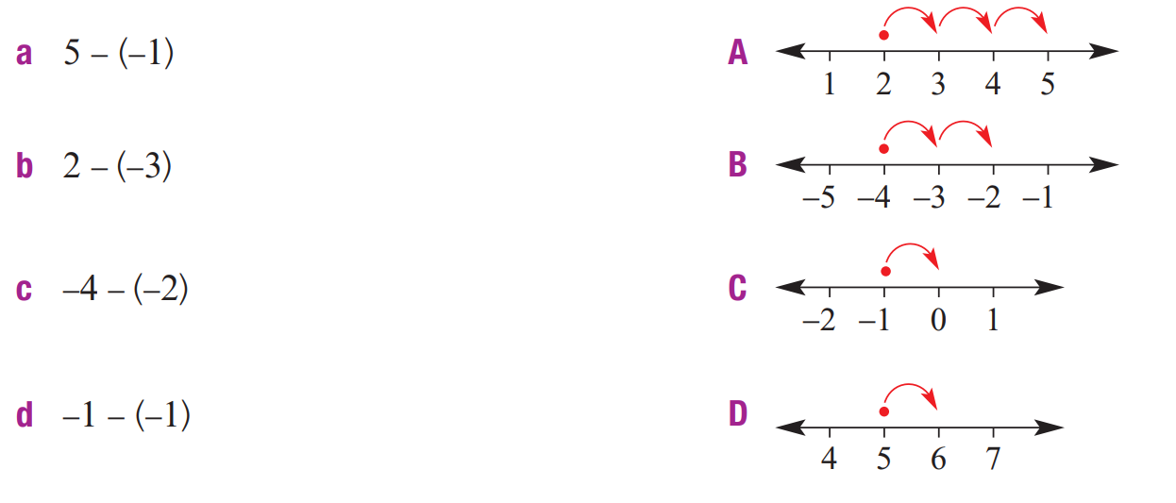

a – D, b- A, c- B, d- C
- Answer these questions.
- $5+3$  8 | - $3+5$  8 | - $-3+5$  2 | - $5+(-3)$  2
- $-5+(-3)$  $$-8$$ | - $-5+3$  $$-2$$ | - $-5-3$  $$-8$$ | - $-3-5$  $$-8$$
- $3-5$  $$-2$$ | - $3-(-5)$  8 | - $-3-(-5)$  2

- Answer these questions
- $-21÷(-3)$  7 | - $-45÷9$  $$-5$$ | - $5×(-4)$  $$-20$$ | - $8×(-5)$  $$-40$$
- $-10÷(-2)$  5 | - $-15÷5$  $$-3$$ | - $18÷(-3)$  $$-6$$ | - $14÷(-7)$  $$-2$$
- $-10×4$  $$-40$$ | - $3×(-6)$  $$-18$$ | - $8×4$  32 | - $\left(-7\right)×0$  0

- Answer these questions.
- $-4+6$  2 | - $-5+8$  3 | - $-1+3$  2 | - $-4+7$  3
- $2+(-3)$  $$-1$$ | - $-1+(-4)$  $$-5$$ | - $-2+(-3)$  $$-5$$ | - $-1+(-4)$  $$-5$$
- $-2+(-3)$  $$-5$$ | - $-6+6$  0 | - $-7+4$  $$-3$$ | - $-6+2$  $$-4$$
- $-7+2$  $$-5$$ | - $-5+(-5)$  $$-10$$ | - $5+(-5)$  0 | - $-7+7$  0
- $5+(-4)$  1 | - $6+(-7)$  $$-1$$ | - $-7+8$  1 | - $-3+2$  $$-1$$
- $-5+7$  2 | - $-5+3$  $$-2$$ | - $-5+3$  $$-2$$ | - $6+(-4)$  2

- Write a different calculation for the following and evaluate the result.
- $28+(-78)$  $$-50$$ | - $-28+(-76)$  $$-104$$ | - $76+(-28)$  48 | - $18+(-76)$  $$-58$$
- $-18+(-76)$  $$-94$$ | - $76+(-18)$  58 | - $-76+(-18)$  $$-94$$ | - $-77+(-19)$  $$-96$$

Development
- Find the missing number.
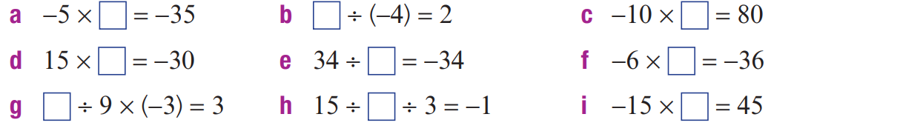  7 | $$-8$$ | $$-8$$
$$-2$$ | $$-1$$ | 6
$$-3$$ | $$-5$$ | $$-9$$

- Find the missing number.
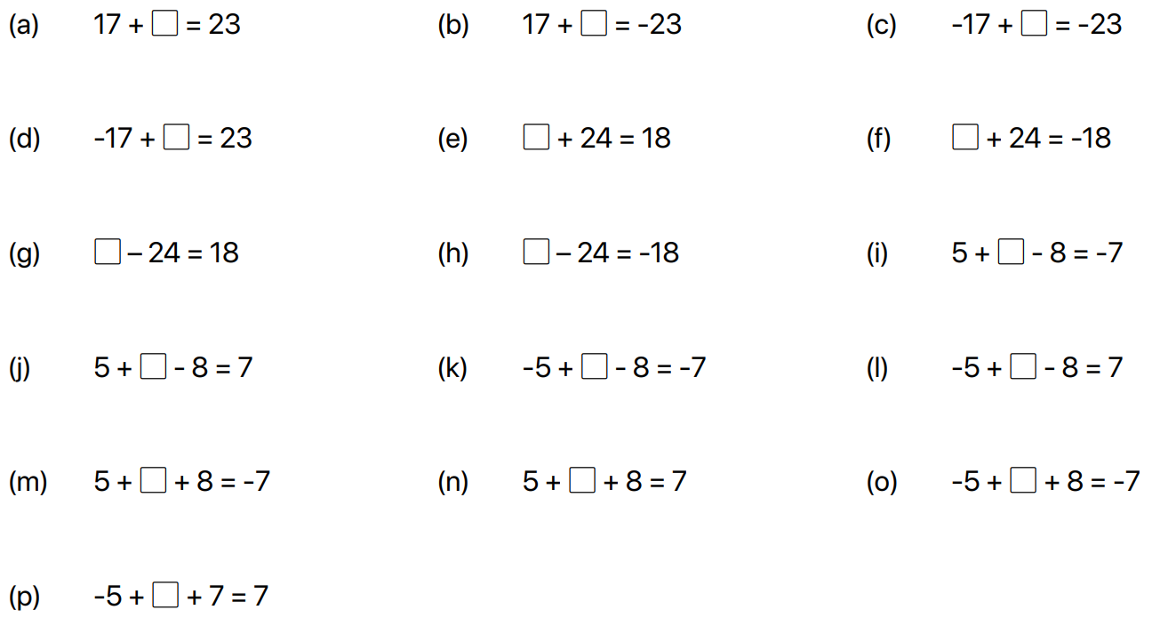  6 | $$-6$$
$$-40$$ | $$-42$$
$$-6$$ | 42
40 | 6

- Calculate the answer without a number line.
a $(-20)+18$  $$-2$$ | b $(-39)+41$  $$2$$ | c $39-51$  $$-12$$
d $21-26$  $$-5$$ | e $(-18)+19$  1 | f $100-200$  $$-100$$
g $(-95)+350$  255 | h $(-49)-130$  $$-179$$ | i $(-210)-120$  $$-330$$
j $62-84$  $$-22$$ | k $-21-26$  $$-47$$ | l $\left(-99\right)+68$  $$-31$$
l $(-3125)-2125$  $$-5250$$ | m $(-4000)+4000$  0 | n $(-5500)+6700$  $$1200$$

- Find the missing number.
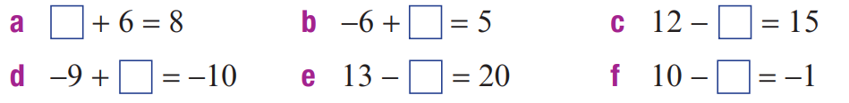  2 | 11 | $$-3$$
$$-1$$ | $$-7$$ | 11
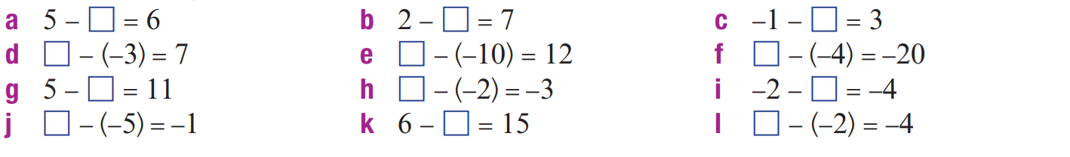  $$-1$$ | $$-5$$ | $$-4$$
4 | 2 | $$-24$$
$-6$ | $$-5$$ | 2
$$-6$$ | $$-9$$ | $$-6$$
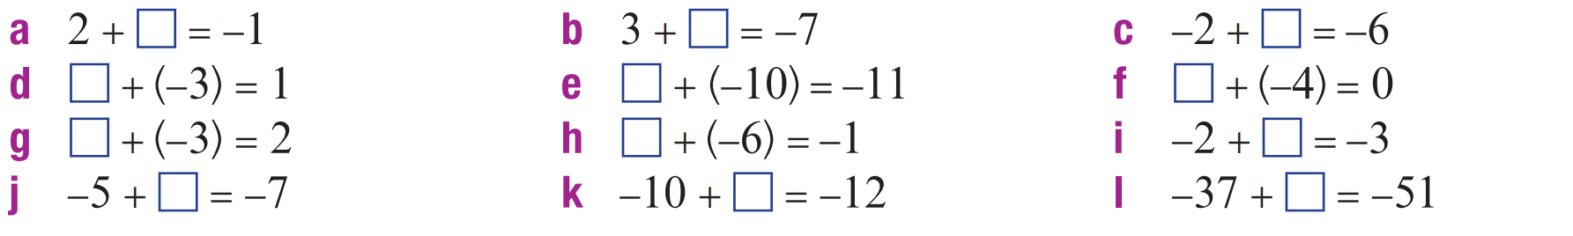  $$-3$$ | $$-10$$ | $$-4$$
4 | $$-1$$ | 4
5 | 5 | $$-1$$
$$-6$$ | 9 | 3

- Complete the pyramid. Each rectangle is the sum of the two rectangles directly below.
$$-29$$  $$-8 -21$$ | 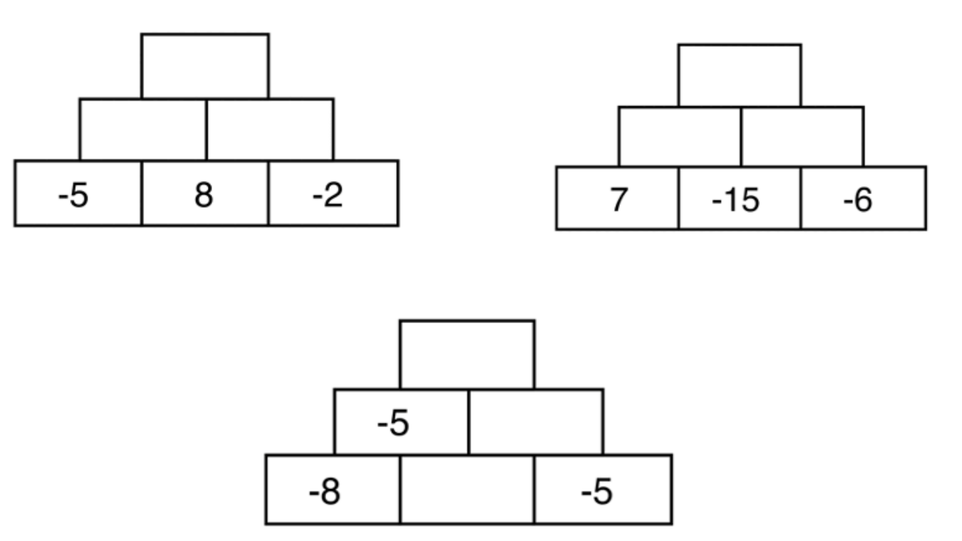  $$-7$$  $$-2$$  $$3$$

Mastery
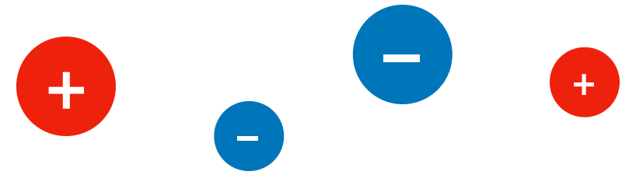
- Some numbers are represented by counters. The larger the counter, the larger the magnitude. Same size counters have the same magnitude.

Use the number line to show the possible positions of the numbers.
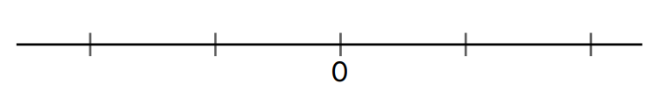

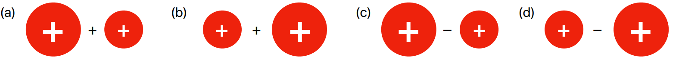
State whether the results of these calculations have a positive, negative, or zero answer.
p | p | p | n
0 | n | p | n
0 | p | 0 | n
0 | 0 | 0 | p

- Create an example of an addition that belongs in each box.
Some boxes are not possible to fill in – decide which ones.
 | Sum is positive | Sum is zero | Sum is negative
Positive $+$ Positive |  | Not possible :( | Not possible :(
Negative $+$ Positive
Positive $+$ Negative
Negative $+$ Negative | Not possible :( | Not possible :(

- Create an example of a subtraction that belongs in each box.
Some boxes are not possible to fill in – decide which ones.
 | Difference is positive | Difference is zero | Difference is negative
Positive $-$ Positive
Negative $-$ Positive | Not possible :( | Not possible :(
Positive $-$ Negative |  | Not possible :( | Not possible :(
Negative $-$ Negative

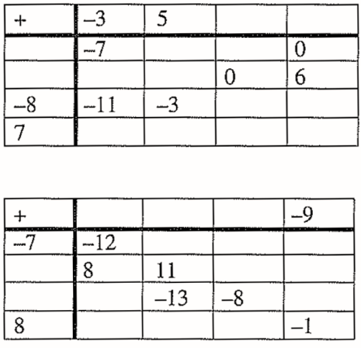
- Complete the tables.
- ‘  $$-3 5 -2 4$$  $$-4 -7 1 -6 0$$  $$2 -1 7 0 6$$  $$-8 -11 -3 -10 -4$$  $$7 4 12 5 11$$ | $$-5 -2 3 -9$$  $$-7 -12 -9 -4 -16$$  $$13 8 11 16 4$$  $$-11 -16 -13-8 -20$$  $$8 3 6 11 -1$$

- Write a multiplication or division symbol to make a true statement.
- 2 ……… $(-3)$ ……… $\left(-6\right)=1$  $$× ÷$$ | - $-25$ ……… $(-5)$ ……… $3=15$  $$÷ ×$$
- $-36$ ……… $2$ ……… $\left(-3\right)=216$  $$× ×$$ | - $-19$ ……… $(-19)$ ……… $15=15$  $$÷ ×$$

- [UKMT JMC 2010]
What is $2010+\left(+2010\right)+\left(-2010\right)-\left(+2010\right)-(-2010)$?
………………………………………………………………………………………………………………
2010
- If $-50-70=-120$, then what is:
- $-51-69$  $$-120$$ | - $-51-71$  $$-122$$ | - $-71-51$  $$-122$$ | - $-73-49$  $$-122$$

- Find the next three numbers in these sequences.
  - $3$ $-9$ $27$ ………… ………… …………
$$-81 243 -729$$
  - $-32$ $16$ $-8$ ………… ………… …………
$$4 -2 1$$
  - $600$ $-480$ $384$ ………… ………… …………
$$-307.2 245.76 -196.608$$

- The rectangular boxes represent the number halfway between the two connecting circles.
- Use the numbers $-10, -2, 10$ to complete the puzzle.  $$-2$$  $$10 -10$$ | - Use $-100, -75, -50, -30, -10$ to complete the puzzle.  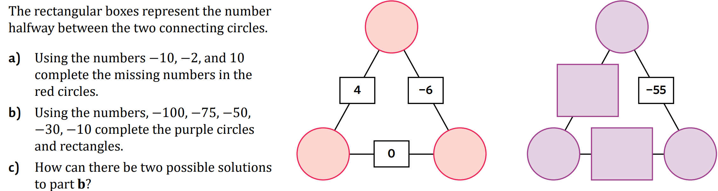  $$-10$$  $$-30$$  $$-50 -75 -100$$

Order of Operations with Integers

- Order of Operations with Integers
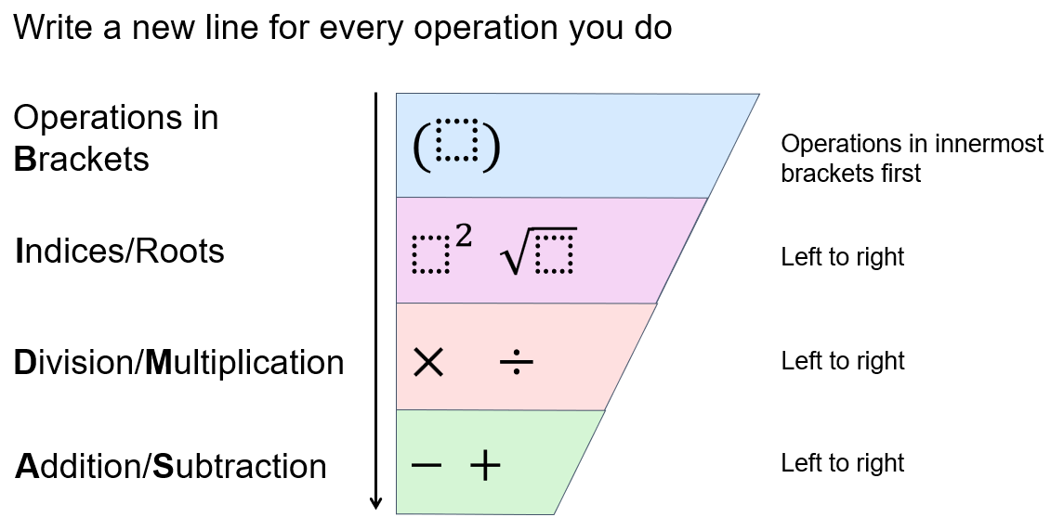

- It is important you identify when a minus sign represents a negative or a subtraction to be able to follow the order correctly.

- Example Evaluate expressions with negative integers using order of operations
$4+2×(-3)$  ¯¯¯¯¯¯¯  $=4+\left(-6\right)$  $=-2$ | Which operation was done first?  We …………… before we add.  How did we know $4+\left(-6\right)=-2$?  This is the same as ………………, which makes $-2$
$(30+5)-10÷(-2)$  ¯¯¯¯¯¯¯  ¯¯¯¯¯¯¯  $=35-10÷(-2)$  $=35-(-5)$  $=40$ | Which operation was done first and why?  We did $30+5$ first because it was inside ……………  Which operation was done second?  ……………………………………………………

- Guided Practice
- $6+2×\left(-4\right)$ | - $1-48÷12$
- $8×9-15÷(-3)$ | - ${\left(-3\right)}^{2}×4$

Foundation
- Which operation is done first in each of the following computations?
Do not evaluate the answer yet.
- $-2÷2+1$  $$-2÷2$$ | - $8×(-6)-4$  $$8×\left(-6\right)$$ | - $-3+2×(-6)$  $$2×\left(-6\right)$$
- $7-(-8)÷4$  $$\left(-8\right)÷4$$ | - $(-2+3)÷5$  $$(-2+3)$$ | - $-6÷\left(4-\left(-2\right)\right)$  $$4-(-2)$$
- $-4×3÷(-6)$  $$-4×3$$ | - $\left(2+3×\left(-2\right)\right)+1$  $$3×(-2)$$ | - $-11÷\left(7-2×\left(-2\right)\right)$  $$2×\left(-2\right)$$
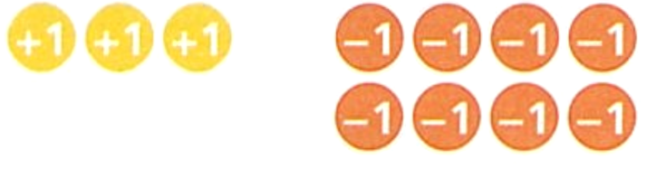
- Use the counters to work out $3+ 4×(-2)$

$$-5$$
- Underline the part of each calculation that you need to work out first.
Then work out the answers.
- $5+10×\left(-2\right)$  $$-15$$ | - $1+8×3-4$  $$21$$ | - $\left(2+5\right)×6+2$  44
- $5-10×\left(-2\right)$  $$25$$ | - $1-8×3-4$  $$-27$$ | - $\left(-2+5\right)×\left(-6\right)+3$  $$-15$$
- $-6-3×5$  $$-21$$ | - $11+10÷\left(-2\right)$  $$6$$ | - $11×(2-10)$  $$-88$$
- $6-3×5$  $$-9$$ | - $11-10÷\left(-2\right)$  $$16$$ | - $-11×\left(2-10\right)$  88
- $7×\left(3-5\right)$  $$-14$$ | - $4-10÷5$  $$2$$
- $-7×\left(3-5\right)$  $$14$$ | - $4-10÷\left(-5\right)$  6
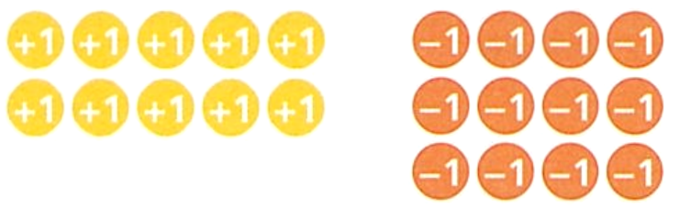
- Use the counters to work out $2×5 + 3×(-4)$

$$-2$$
- Underline all the operations that have equal priority, then calculate the answer.
- $4×\left(-2\right)+3×5$  7 | - $\left(2-10\right)÷\left(9-7\right)$  $$-4$$ | - $3+4×\left(-6\right)÷2$  $$-9$$
- $4×\left(-2\right)+3×\left(-5\right)$  $$-23$$ | - $\left(2-10\right)÷\left(7-9\right)$  $$4$$ | - $3-4×\left(-6\right)÷2$  $$15$$
- $4×\left(-2\right)-3×5$  $$-23$$ | - $3-4×\left(-6\right)÷2$  15 | - $3+4×\left(-6\right)÷\left(-2\right)$  15

- Use order of operations to calculate the answer to the following. Show each step of working out. Check your answer using a calculator.
- $2+3×(-3)$  $$-7$$ | - $9+10÷(-5)$  7 | - $20+(-4)÷4$  19
- $18+(-9)×1$  9 | - $10-2×(-3)$  16 | - $10-1×(-4)$  14
- $-8-(-7)×2$  6 | - $-2×4+8×(-3)$  $$-32$$ | - $12÷(-6)+4÷(-2)$  $$-4$$
- $-30÷5-6×2$  $$-18$$ | - $-2×3-4÷(-2)$  $$-4$$ | - $8×(-2)-(-3)×2$  $$-10$$

Development
- Use order of operations to calculate the answer to the following. Show full working out.
Check your answer using a calculator.
- $\left(3+2\right)×\left(-2\right)$  $$-10$$ | - $-3×(-2+4)$  $$-6$$
- $-1×\left(7-8\right)$  1 | - $\left(8-4\right)÷(-2)$  $$-2$$
- $10÷\left(4-\left(-1\right)\right)$  2 | - $\left(24-12\right)÷\left(16+\left(-4\right)\right)$  1
- $-2×\left(8-4\right)+\left(-6\right)$  $$-14$$ | - $-2-3×\left(-1+7\right)$  $$-20$$
- $1-2×\left(-3\right)÷\left(-3-\left(-2\right)\right)$  $$-5$$ | - $\left(-3+\left(-5\right)\right)×\left(-2-\left(-1\right)\right)$  8
- $-3÷\left(-1+4\right)×6$  $$-6$$ | - $-5-\left(8+\left(-2\right)\right)+9÷(-9)$  $$-12$$

- A debt of $550 is doubled and then $350 of debt is removed each month for 3 months.
What is the final balance?
……………………………………………………………………………………...………………………
………………………………………………………………………………………………………………
………………………………………………………………………………………………………………
$$-50$$

- Use order of operations to evaluate the following. Remember that there are invisible brackets enclosing the numerator and denominator of a fraction. Check your answer using a calculator.
- $\frac{8-4}{-2}$  $$-2$$ | - $\frac{10}{4-(-1)}$  2
- $\frac{24-12}{16+(-4)}$  1 | - $1-\frac{2×(-3)}{-3-(-2)}$  $$-5$$
- $\frac{3}{1+4}$ $×6$  $$\frac{18}{5}$$ | - $\frac{-(-2)-2×(-5)}{-3}$  $$-4$$
- $\frac{2×\left(-2\right)-5×(-5)}{-3}$  $$-7$$ | - ${\left(\frac{-4+\left(-4\right)}{4-\left(-4\right)}\right)}^{2}$  1
- Work out the missing numbers in these calculations.
6 | 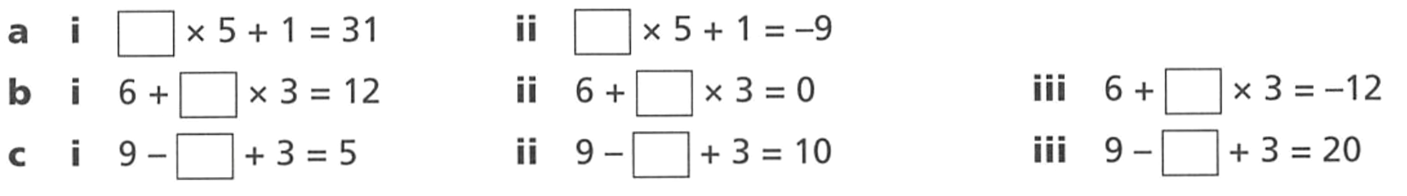  $$-2$$
2 | $$-2$$ | $$-6$$
7 | 2 | $$-8$$
- Classify each of the following statements as true or false.
  - $-4 + 2 × 3 = -4 + (2 × 3)$
T
  - $-4 + 2 × 3 = (-4 + 2) × 3$
F
  - $8 × \left(2 - \left(-2\right)\right) = 8 × 4$
T
  - $8 × \left(2 - \left(-2\right)\right) = 8 × 0$
F
  - $-40 - 20 ÷ (-5) = (-40 - 20) ÷ (-5)$
F
  - $-40 - 20 ÷ (-5) = -40 - \left(20 ÷ \left(-5\right)\right)$
T
- Use the given numbers to make a true equation.
$$-7 -6 2$$ | 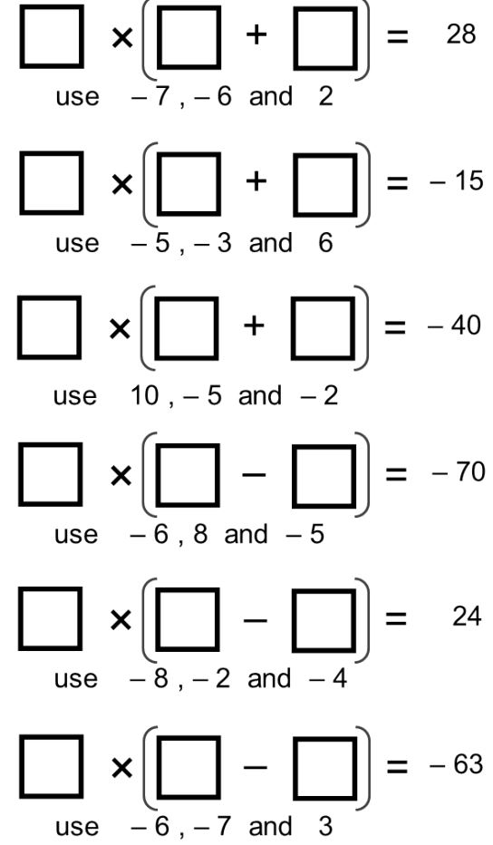  $$-5 6 -3$$
$$-5 10 -2$$ | $$-5 8 -6$$
$$-4 -8 -2$$ | $$-7 3 -6$$
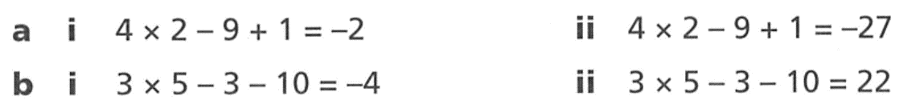
- Insert brackets into the calculations to make the answer correct.

a i: (9+1) ii: (2-9)

b i: (5 – 3) ii: (3 – 10)

- Evaluate the following:
- $-21+2×6-3$  $$-12$$ | - $\frac{-135}{\left(75-30\right)}$  $$-3$$ | - ${\left(-5\right)}^{2}×6÷\left[10×5÷\left(-10\right)\right]$  $$-30$$
- $\left(-4+7\right)×\left(16-9\right)$  21 | - ${\left(7-10\right)}^{3}+21÷-7$  $$-30$$ | - $120-20×5-40÷2÷5$  16
- $234÷\left[103-\left(72-86\right)\right]$  2 | - $\frac{25×2-(-5)}{11}$  5 | - $\left\{\left[79-\left(2-3\right)\right]÷4\right\}-1×\left(-7-3\right)$  30

Mastery
- Insert brackets to make each statement true.
  - $-10÷4+1=-2$
(4 + 1)
  - $-5-1÷(-6)=1$
(–5 – 1)
  - $50×7-8×(-1)=50$
(7 – 8)
  - $-3+9÷(-7)+5=-3$
(–3 + 9) ((–7) + 5)
  - $32-(-8)÷(-3)+7=10$
(32 – (–8)) ((–3) + 7)

- Given that $5^{3} = 5 × 5 × 5$, is the answer to each of the following positive or negative?
(you do not need to do any calculations!)
- $-6×(-4)×(-8)×(-108)×(-96)$  Negative | - $100÷(-2)÷2÷(-5)$  positive
- ${\left(-3\right)}^{3}$  Negative | - $-1×{\left(-2\right)}^{4}$  negative
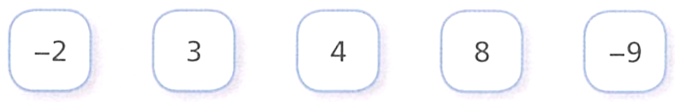
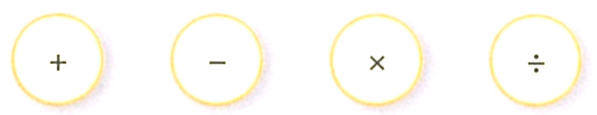
- Here are some digit and operation cards.


Choose any 3 digits and 2 operations to go into these boxes. You can only use each card once.

What answer do you get? …………………………………………………………………………
Depends on the cards you chose.
Find two ways to make the answer zero.
$$-2×4+8$$
$$8÷4 + -2$$
Other answers are possible.
- Show that the answer to $6×11-3×(6-2)-2×(11-3)-2×3$ is 32.

- Evaluate the following.
- ${\left(-2\right)}^{3}-{\left(-2\right)}^{2}$  $$-12$$ | - $\frac{\left(4-12\right)×(-3--7)}{4}$  $$-8$$ | - $-20÷[-2×4-3×-6]$  $$-2$$
- $\frac{-7+3}{-11--7}$  $$1$$ | - ${\left(-3--7\right)}^{2}×3$  $$48$$ | - ${\left(-1\right)}^{100}$  1
- ${\left(-2×3\right)}^{3}-{\left(-3--2\right)}^{3}$  $$-215$$ | - ${\left(-4--6\right)}^{\left(-2--3\right)}-$ $\frac{3--7}{5+\left(-10\right) }$  4

- Ed thinks of a number. He takes away four lots of this number from itself. He is left with −36. What was Ed’s original number?

12

Challenge Exercise
- Evaluate:
- ${\left(-1\right)}^{1000}$  $$1$$ | - ${\left(-1\right)}^{1001}$  $$-1$$

- Find the number that must be placed in the box to make the following statement true.
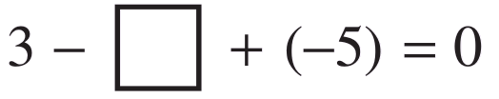

$$-2$$
- Submarine A is 658 metres below sea level.
Submarine B is 177 metres higher than submarine A.
Submarine B is ………… metres below sea level.

$$-658+177=-481$$
So 481 metres below sea level
- [UKMT JMO 2013]
What is the value of $\left(\left(1-1\right)-1\right)-\left(1-\left(1-1\right)\right)$?

$$-2$$
- [UKMT JMO 2007]
What is the value of $1^{5}-2^{4}+3^{3}-4^{2}+5^{1}$

$$1$$
- What is the least product you could obtain by multiplying any two of these numbers?
$-8, -6, -1, 1,$ and 4

$$-32$$

- The temperature in town A is 19.4°C. The temperature in town B is 27.6°C less than the temperature in town A. The temperature in town C is −6.2°C.
Find the midpoint of the temperature in town B and the temperature in town C.

Town B: $\left(19.4-27.6\right)=-8.2$
Average of B and C: $\frac{-8.2+\left(-6.2\right)}{2}$ $=-7.2°C$
- The temperature in New York on a dreary winter day was falling at a steady rate of 2°C per hour after 5 p.m. If the temperature at 8 p.m. was −8°C, find the temperature at:
  - 10 p.m.

$$-12°C$$
  - 6 p.m.

$$-4°C$$

- The integers on the edges of each triangle below are the sum of two adjacent integers inside the circles. Find the numbers in the circle.
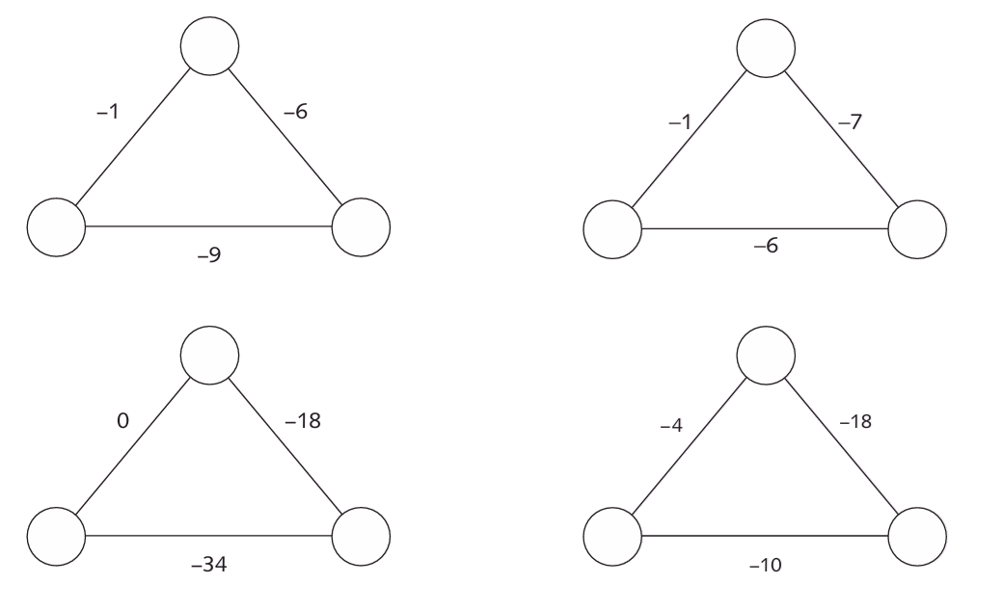  Going clockwise from the top: $1, -7, -2$ | $$-1, -6, 0$$
$$8, -26, -8$$ | $$-6, -12, 2$$

- Put the three numbers $4, -2$ and $-7$ into the boxes below such that:
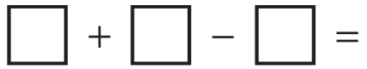  $-1$  $$4, -7, -2$$ | $9$  $$4, -2, -7$$ | $-13$  $$-7, -2, -4$$

- Put the three numbers $5, -5$ and $-4$ into the boxes below such that:
$6$  $$5, -4, -5$$ | $-14$  $$-5, -4, 5$$ | $4$  $$5, -5, -4$$

- Place brackets in each statement below to make the statement true.
  - $5+\left(-3\right)×3+4=14$
$$\left(5+\left(-3\right)\right)×\left(3+4\right)=14$$
  - $5+\left(-3\right)×3+4×2=4$
No brackets required
  - $5-5×6+7×6-5=37$
$$\left(5-5\right)×6+7×6-4=37$$

- Jacqui has $428 in her bank account. If she withdraws $25 every week:
  - How much has she in her account after:
    - 6 weeks?
$$\$428-\$6×25-\$278$$
    - $n$ weeks?
$$\$\left(428-25n\right)$$
  - After how many weeks will her account be in overdraft (i.e. be negative)?

18th week
- Jayden's bank balance is −$120 but he deposits $9 each day for the next 20 days.
  - On which day will his bank balance become positive?

14th day
  - What will be his bank balance after 20 days?

$60
- This is a magic square. All rows, columns and diagonals have the same sum.
Complete the magic square.
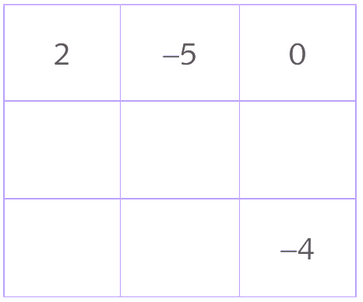

Missing numbers:
$$-3, -1, 1$$
$$-2, 3$$

  - Find the value of 2 − 4 + 6 − 8 + 10 − 12 by:
    - Working from left to right
$$-6$$
    - Pairing the numbers: $\left(2-4\right)+\left(6-8\right)+\left(10-12\right)$
$$-6$$
  - Evaluate $2-4+6-8+10-12+14-16+$…$+98-100$.

$$-50$$

- Find the value of:
  - $(1-3)+(5-7)+(9-11)+(13-15)+(17-19)$

$$-10$$
  - $2-4+6-8+10-12+14-16+18-20$

$$-10$$
  - $1-3+5-7+9-11+13-15+17-18$

$$-9$$
  - $1-2+⋯+99-100$

$$-50$$
  - $1-3+⋯+97-99$

$$-50$$
  - $1-3+5-7+9-11+…+101-103$

$$-52$$

- Fiona is playing a game. She throws 8 balls at a target, one at a time. Each hit is worth 5 points. Each miss is worth −3 points. Fiona hits the target with 5 of the balls and misses with the rest.
  - How many points does Fiona score?

16
  - Chris throws 9 balls at the target, one at a time.
Is it possible for Chris to score the same number of points as Fiona?

5H 4M: 25 – 12 = 13
4H 5M: 30 – 9 = 21
no
- Tristan is taking part in a maths competition.
Each correct answer is worth 12 points and each incorrect answer is worth −8.
If Tristan chooses not to answer a question, it is worth −3 points.
There are 10 questions in total.
Tristan answered 3 questions correctly, 6 questions incorrectly and left 1 blank.
Work out Tristan's final score.

$$(3×12)+(6×-8)+\left(1×-3\right)=-15$$
- The average of five numbers was 2. If the smallest number is deleted, the average is 4.
What is the smallest number?

$$-6$$
- Evaluate $100+99-98-97+96+95-94-93…+4+3-2-1$

100
- If $x > 3$ and $y < 5$, work out if the following expressions are positive or negative.
- $3-x$  negative | - $\frac{y - 5}{3 - x}$  Positive, as you are dividing two negatives
- $\left(x - 3\right)\left(5 - y\right)$  Positive, as you are multiplying two positives | - ${\left(3 - x\right)}^{2}\left(5 - y\right)$  ${\left(3-x\right)}^{2}$ is always positive, $5-y$ positive  So the result is positive.

- A quiz has twenty questions with 7 points awarded for each correct answer, 2 points deducted for each wrong answer and 0 for each question omitted.
Jack scored 87 points.
How many questions did he omit?

He scored at least 87, so he must have gotten at least 13 right.
13 right, 2 wrong, omitted 5.
Omitted 5 is the only possible answer.

